*A project report on*

**COMPARITIVE AND PREDICTIVE ANALYSIS OF CRIME IN FIRST WORLD AND THIRD WORLD COUNTRIES**

**(INDIA vs. USA)**

*Submitted in partial fulfilment for the award of the degree of*

**BSc Computer Science**

*By*

**PREETI RACHEL JASPER (17BCS0003)**



**SITE**

APRIL, 2020

*A project report on*

**COMPARITIVE AND PREDICTIVE ANALYSIS OF CRIME IN FIRST WORLD AND THIRD WORLD COUNTRIES**

**(INDIA vs. USA)**

*Submitted in partial fulfilment for the award of the degree of*

**BSc Computer Science**

*By*

**PREETI RACHEL JASPER (17BCS0003)**



**SITE**

APRIL, 2020

**DECLARATION**

I hereby declare that the thesis entitled “COMPARITIVE AND PREDICTIVE ANALYSIS OF CRIME IN FIRST WORLD AND THIRD WORLD COUNTRIES” submitted by me, for the award of the degree of BSc Computer Science, VIT is a record of the bona fide work carried out by me under the supervision of Prof Chemmalar Selvi G.

I further declare that the work reported in this thesis has not been submitted and will not be submitted, either in part or in full, for the award of any other degree or diploma in this institute or any other institute or university.

**Place: Vellore**

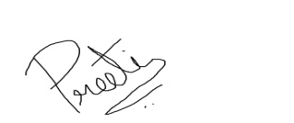

**Date: 22/5/2020**

**Signature of the Candidate**

**CERTIFICATE**

This is to certify that the thesis entitled “COMPARITIVE AND PREDICTIVE ANALYSIS OF CRIME IN FIRST WORLD AND THIRD WORLD COUNTRIES**”** submitted by PREETI RACHEL JASPER (17BCS0003), SITE, VIT, for the award of the degree of BSc Computer Science is a record of bona fide work carried out by  
him/her under my supervision.

The contents of this report have not been submitted and will not be submitted  
either in part or in full, for the award of any other degree or diploma in this institute or  
any other institute or university. The Project report fulfils the requirements and regulations of  
VIT and in my opinion meets the necessary standards for submission.

**Signature of the Guide**  **Signature of the HoD**

**Internal Examiner**  **External Examiner**

**ABSTRACT**

According to the National Crime Records Bureau of India, a crime against women is committed every 3 minutes, and the rate of crime showed an increase of approximately 50% from the years 2011- 2015 ( in four years). However, data studies show that crime against women per capita in India is low compared to other countries. This new found information helps us understand that maybe the increased rate of crime in India might be directly related to population growth India has experienced in the past decade. This poses the question, what will be the state of our country in future years? We strive for a safer country for our mothers and sisters and this project aims to provide insight regarding the question. Exploratory data analytics techniques will be used to assess the datasets and supervised learning techniques will be applied to draw a predictive conclusion.

Predictive analysis is concerned with the branch of data mining used to predict future patterns and trends. This modelling technique can be used to aid society. This research aims to foresee the crime patterns against women in India. In recent years, crime against women has skyrocketed and understanding past data can help us come up with insightful patterns that describe the current state of crime and assault in India. The datasets of the past years will be studied using extensive EDA (Exploratory Data Analysis) techniques that will help us understand the problems women and girls of India face. The data will then be cleaned and supervised learning techniques will be executed to predict future trends in crime rates with time. The project aims to help the women of India by using technological advancements in the area of data science to predict the future state of the country.

*i*

**ACKNOWLEDGEMENT**

It is my pleasure to express with deep sense of gratitude to Mrs Chemmalar Selvi G, Assistant Professor, School of Information Technology and Engineering, Vellore Institute of Technology, for her constant guidance, continual encouragement, and understanding; more than all, she taught me patience in my endeavour. My association with her is not confined to academics only, but it is a great opportunity on my part of work with an intellectual and expert in the field of Data Analytics.

I would like to express my gratitude to G. Viswanathan, Sekar Viswanathan, Dr. Anand A. Samuel, Dr. S. Narayanan, and Dr. Balakrushna Tripathy, SITE, for providing with an environment to work in and for his inspiration during the tenure of the course.

In jubilant mood I express ingeniously my whole-hearted thanks to Dr. Malaserene. Head of Department, all teaching staff and members working as limbs of our university for their not-self-centred enthusiasm coupled with timely encouragements showered on me with zeal, which prompted the acquirement of the requisite knowledge to finalize my course study successfully. I would like to thank my parents for their support.

It is indeed a pleasure to thank my friends who persuaded and encouraged me to take up and complete this task. At last but not least, I express my gratitude and appreciation to all those who have helped me directly or indirectly toward the successful completion of this project.

**Place: Vellore **

**Date: 22/5/2020 Preeti Rachel Jasper**

*ii*

**CONTENTS**

**LIST OF FIGURES…………………………………………………………………………………v**

**LIST OF TABLES…………………………………………………………………………………..vii**

**LIST OF ABBREVIATIONS………………………………………………………………………viii**

**CHAPTER 1: INTRODUCTION....................................................................................................**

**1.1 MOTIVATION AND OBJECTIVE**

**1.2 OVERVIEW**

**1.3 ADVANTAGES OF DATA ANALYTICS**

**CHAPTER 2: LITERATURE SURVEY**

**2.1 REVIEW OF PAST WORK**

**2.2 OUR WORK**

**CHAPTER 3: DESIGN OF THE PROJECT**

**3.1 METHODOLOGY**

**3.2 DATA COLLECTION**

**3.3 EXPLORATORY DATA ANALYSIS**

**3.4 DATA CLEANING**

**3.5 PREDICTIVE ANALYSIS**

**3.6 LINEAR REGRESSION**

**3.7 K MEANS**

**3.8 ARCHITECTURE AND DESIGN**

**3.8.1 FLOWCHART**

**3.8.2 USE CASE DIAGRAM**

**3.8.3 CLASS DIAGRAM**

**3.8.4 DATA FLOW DIAGRAM**

**CHAPTER 4: IMPLEMENATION**

**4.1 UNDERSTANDING INDIA**

**4.2 EXPLORATORY DATA ANALYSIS (INDIA)**

**4.3 LINEAR REGRESSION (INDIA)**

*iii*

**4.4 UNDERSTANDING USA**

**4.5 EXPLORATORY DATA ANALYSIS (USA)**

**4.6 LINEAR REGRESSION (USA)**

**4.7 COMPARISON OF INDIA AND USA**

**4.8 K MEANS CLUSTERING**

**CHAPTER 5: RESULT AND DISCUSSION**

**5.1 RESULT ANALYSIS**

**5.2 INFERENCE**

**CHAPTER 6: CONCLUSION AND FUTURE WORK**

**6.1 CONCLUSION**

**6.2 FUTURE WORK**

**REFERENCES………………………………………………………………………………….v**

**APPENDICE……………………………………………………………………………………vi**

*iv*

**LIST OF FIGURES**

**Figure 1.World map representation…………………….……………………………...…V**

**Figure 2. India map representation……………………………………………………….V**

**Figure 3.USA map representation ………………………………………………………..V**

**Figure 4.Methodology……………………………………….…………………………….V**

**Figure 5.Linear Regression ……………………………………………………………….V**

**Figure 6.Flowchart………………………………………………………………………...V**

**Figure 7.Use Case Diagram………………………………………………………………..V**

**Figure 8.Class Diagram ……………………………………………………………………V**

**Figure 9.Data Flow Diagram 1…………………………………………………………….V**

**Figure 10.Data Flow Diagram 2…………………………………………………………...V**

**Figure 11.Correlogram of I/P values……………………………….…………………….V**

**Figure 12.Box plot of rape-X and year-Y…………………………………………………V**

**Figure 13.Number of rapes per year in all of India for the decade……………………..V**

**Figure 14.World rape rate per capita…………………………………………………….V**

**Figure 15.India crime rate per capita…………………………………………………….V**

**Figure 16.Normalization……………………………………………………………..……V**

**Figure 14.Using Linear Regression………………………………………………………v**

**Figure 15.Dot plot of rape/year before normalization ….……………………………V**

**Figure 16.Regression line for India before normalization……………………………V**

**Figure 17.Actual vs. Predicted values of crime in India ………………………………………V**

**Figure 18.Dot plot after normalization…………………………………………V**

**Figure 19.Distribution plot (India)………………………………V**

**Figure 20.c and m calculation………………………………………………………V**

**Figure 21.Actual vs Predicted after normalization…………………………………v**

**Figure 22.Result Analysis……………………………….……………………………V**

**Figure 23.USA Rape legacy over the decade…………………………………………V**

*v*

**Figure 24. World Map showing intensity of rape in the world vs USA ……………………V**

**Figure 25. Map showing intensity of rape in USA per 100k………………………………V**

**Figure 26. Actual vs Predicted Values ( USA)……………………………………V**

**Figure 27. Regression line for USA ………………………………………………………V**

**Figure 28. Normalization of USA dataset…………………………………………………v**

**Figure 29. Distribution plot for USA ……………………V**

**Figure 30. Actual vs Predicted after Normalization………………………………V**

**Figure 31. Result Analysis (USA)………………………………V**

**Figure 32. Regression line for USA ………………………………………………………V**

**Figure 33. Using Linear Regression………………………………………………………v**

**Figure 34. Regression line for USA ………………………………………………………V**

**Figure 35. Normalization of USA dataset…………………………………………………v**

**Figure 36. Distribution plot for USA ……………………V**

**Figure 37. Actual vs Predicted after Normalization………………………………V**

**Figure 38. Result Analysis (USA)………………………………V**

**Figure 39. Regression line for USA ………………………………………………………V**

**Figure 40. Using Linear Regression………………………………………………………v**

*vi*

**FIGURE OF TABLES**

**Table 1. India STATE/UT crime count head(5) …………….……………………………V**

**Table 2. India STATE/UT crime count tail (5) ………………………………V**

**Table 3. Highest rape counts in India ……………………………………………V**

**Table 4. Lowest rape counts in India ………………………V**

**Table 5. Calculate the null values………………………………………V**

**Table 6. Describe() function on Country dataset……………………………………V**

**Table 7. USA state/ut head(5)………………………………………………………v**

**Table 8. USA state/ut tail(5)…………………………….……………………………V**

**Table 9. Linear regression head(5)…………………………………………V**

**Table 10. Actual vs Predicted after normalization……………………V**

*vii*

**LIST OF ABBREVATIONS**

**NCRB- National Crime Records Bureau of India**

**EDA- exploratory data analysis**

**LR- linear regression**

**DBSCAN-** **Density-based spatial clustering of applications with noise**

**PCA- Principal component analysis**

**USA-** **United States**

**OGD-** **Open Government Data**

**DF- Data frame**

**CSV- comma-separated values**

**JSON-** **JavaScript Object Notation**

**TR- Table Row**

**TD- Table Definition**

**TH-Table head**

**DISP- Distribution plot**

**HTML- Hypertext Markup Language**

**CSS- Cascading Style Sheets**

*viii*

**Chapter 1**

**Introduction**

**1.1 MOTIVATION AND OBJECTIVE:**

According to the National Crime Records Bureau of India, a crime against women is committed every 3 minutes, and the rate of crime showed an increase of approximately 50% from the years 2011- 2015 ( in four years). However, data studies show that crime against women per capita in India is low compared to other countries. This new found information helps us understand that maybe the increased rate of crime in India might be directly related to population growth India has experienced in the past decade. This poses the question, what will be the state of our country in future years? We strive for a safer country for our mothers and sisters and this project aims to provide insight regarding the question. Exploratory data analytics techniques will be used to assess the datasets and supervised learning techniques will be applied to draw a predictive conclusion.

**1.2 OVERVIEW**

Predictive analysis is concerned with the branch of data mining used to predict future patterns and trends. This modelling technique can be used to aid society. This research aims to foresee the crime patterns against women in India. In recent years, crime against women has skyrocketed and understanding past data can help us come up with insightful patterns that describe the current state of crime and assault in India. The datasets of the past years will be studied using extensive EDA (Exploratory Data Analysis) techniques that will help us understand the problems women and girls of India face. The data will then be cleaned and supervised learning techniques will be executed to predict future trends in crime rates with time. The project aims to help the women of India by using technological advancements in the area of data science to predict the future state of the country

**1.3 ADVANTAGES OF DATA ANALYTICS**

Data analysis is the process of evaluating data using analytical and statistical tools to discover useful information and aid in business decision making. There are a several data analysis methods including data mining, text analytics, business intelligence and data visualization.

* It detects and corrects the errors from data sets with the help of data cleansing. This helps in improving the quality of data and consecutively benefits both customers and institutions such as banks, insurance, and finance companies.
* It removes duplicate information from data sets and hence saves a large amount of memory space. This decreases the cost to the company.
* It helps in showing applicable notices on internet shopping sites dependent on notable information and buy conduct of the clients.
* It decreases banking dangers by recognizing likely false clients dependent on notable information examination. This helps establishments in choosing whether to give advance or charge cards to the candidates or not.
* It is utilized by security organizations for surveillance and checking reason dependent on information gathered by the colossal number of sensors.

**Chapter 2**

**Literature Review**

**2.1 REVIEW OF PAST WORK:**

Latest developments in predictive analytics include ‘Prediction of Crime Rate Using Data Clustering Technique’ where A. Anitha discusses the comparative study of various clustering algorithms that can be used to predict the rate of crime. The paper focused solely on the district of West Bengal and K means, Fuzzy C, DBSCAN and agglomerative methods were used to predict crime rates per district in West Bengal. The usage of unsupervised learning techniques in this case provides the reader with possible groups in which future crime may fall into. This work has fuelled our motivation to consider the accuracy provided by supervised learning techniques such as Linear Regression in predicting future crime rates in India compared to other countries, without limiting the study to just one state.’ Approach of Predictive Modelling on Crime Against Women Problem’, provides insights into the crime against women problem by using least squares simple Linear Regression problem. The author states that considering the population of the country into consideration while performing predictive analysis will provide more accurate results. This paper considers the various categories that come under the umbrella term of ‘Crime against Women’ and narrows down the increased rate of crime per year in areas such as ‘Domestic Violence and Cruelty by Husband or his relatives’. The study concluded that more women were coming forward with complains in the present years which then led to a possible increase in the number of filed complaints in the past few years.

Both studies show an increase in reported cases from the past decade. In 2018, ‘Crime rate prediction using data clustering algorithms’ conducted a comparative study using K means and Fuzzy C clustering techniques on unstructured data including audio and video tapes to develop possible patterns in the nature of crime which can aid the law enforcements to predict future crime patterns and take necessary precautions. The research proposes in-depth studies focussing on smaller and static data sets which can help the user narrow down more accurate predictions. These studies help us understand the demand for predictive analysis to analyse the current state of India’s crime statistics. ‘Crime against Indian Women –Women Crime Susceptibility Indexes: A Principal Component Analysis’ uses PCA to narrow down the four major areas of Crime against women that affect the statistics the most. Cruelty by husband and relatives (45%), Assault with intent to outrage modesty (44%), Dowry Deaths (42%), Kidnapping and Abduction (38%) are the variables contributing to Principal component 1 and maximum variance. By providing these features more importance crime prediction and by using supervised learning techniques, we will aim to yield more accurate answers in our study.

**2.2 OUR WORK:**

We have the data for years 2001 to 2012 for crimes committed against women under different categories. In our work we use extensive EDA (Exploratory Data Analysis) to study the past data to understand the crime statistics against women in India. From the EDA we have understood the states with the highest and lowest rates of rape assaults in India. We provide line charts that help in visualizing the increase in rape from the year 2001 to 2012. We also made use of the Folium library to showcase the rapes per capita in different countries across the world. The data is cleared of all null values to prevent inaccurate results. Predictive analysis will then be done on the data to predict the future trends in crime against women with time. Predictive analytics is the practice of extracting information from existing data sets in order to determine patterns and predict future outcomes and trends. Since the data that we have are labelled and structured, we have decided to use linear regression prediction methods to calculate the future crime rates against women with time.

**RAPE STATISTICS BY COUNTRY 2020**

Rape is unlawful sexual activity typically involving sexual intercourse done forcibly or under threat of injury against a person’s will. Rape is a worldwide problem.

It is estimated that approximately 35% of women worldwide have experienced some form of sexual harassment in their lifetime. In the majority of countries that have data available on rape report that less than 40% of women who experience sexual violence seek help. Less than 10% seek help from law enforcement.

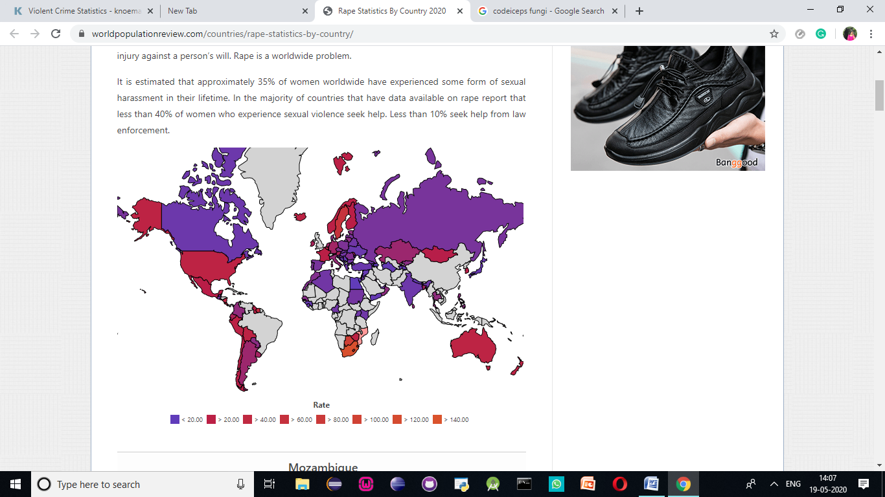

**Figure 1**

Because many women who experience sexual violence rarely report or come forward about their incidences, exact rape numbers are challenging to report. While many countries have laws against the act of sexual assault and violence, many of them are insufficient, inconsistent, and not systematically enforced. While people mostly hear about rape and sexual assault against women, men around the world also experience sexual harassment, sexual assault, and rape every day. Women ages 16-19 are four times more likely to be victims of rape or sexual assault and female college students ages 18-24 are three times more likely to experience sexual assault. Transgender people and those with disabilities are twice as likely to be victims of sexual assault or rape. In the United States, 70% of rape is committed by someone the victim knows.

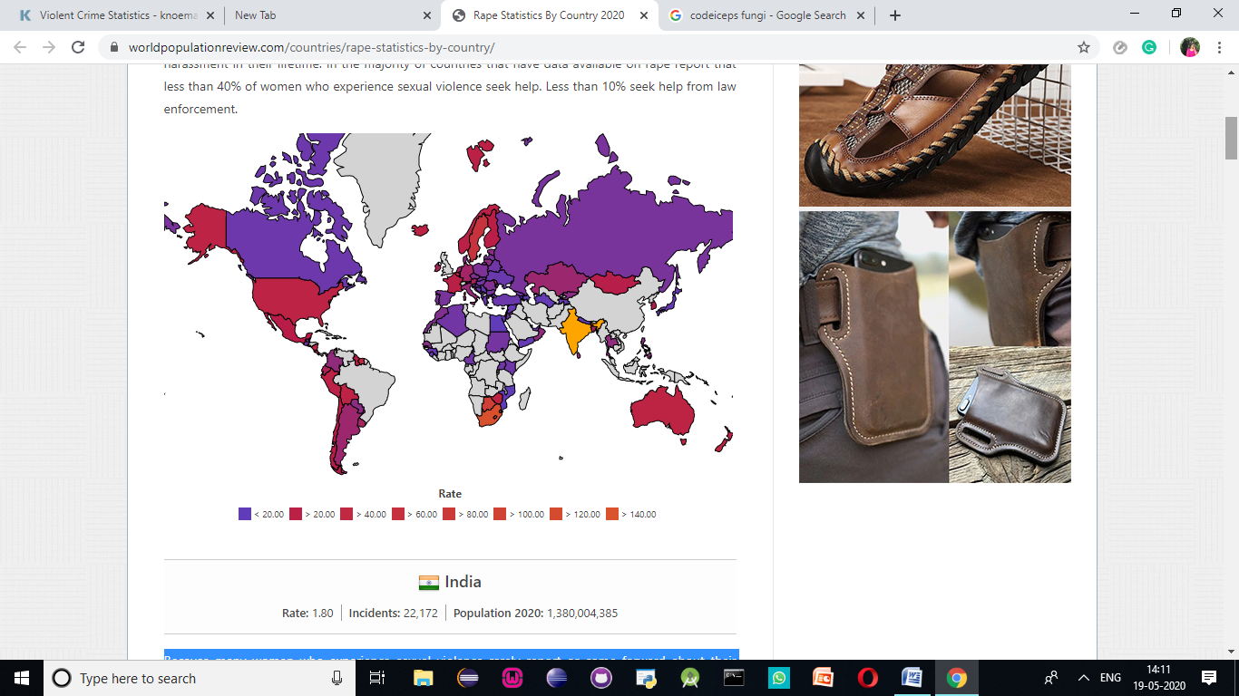

**Figure 2**

The United States has a rape rate of 27.3. As in many other countries, rape is grossly underreported in the United States due to victim shaming, fear of reprisal, fear of family knowing, cases not being taken seriously by law enforcement, and possible lack of prosecution for the perpetrator. Only 9% of rapists in the US get prosecuted and only 3% of rapists will spend a day in prison. 97% of rapists in the United States will walk free.

The ten countries with the highest rates of rape (number of incidents per 100,000 citizens) are:

* South Africa (132.4)
* Botswana (92.9)
* Lesotho (82.7)
* Swaziland (77.5)
* Bermuda (67.3)
* Sweden (63.5)
* Suriname (45.2)
* Costa Rica (36.7)
* Nicaragua (31.6)
* Grenada (30.6)

India is nowhere to be seen among these countries. However, Africa which is another third world country continues to have high rates of rape. This makes us question whether economy has any role to play in the high crime rates against women in different countries

South Africa has the highest rate of rape in the world of 132.4 incidents per 100,000 people. According to a survey conducted by the South African Medical Research Council, approximately one in four men surveyed admitted to committing rape. Although the Parliament of South Africa enacted the Criminal Law (Sexual Offences and Related Matters) Amendment Act in 2007 attempting to amend and strengthen all laws dealing with sexual violence, the rates of reported rape, sexual abuse of children and domestic violence have continued to rise.

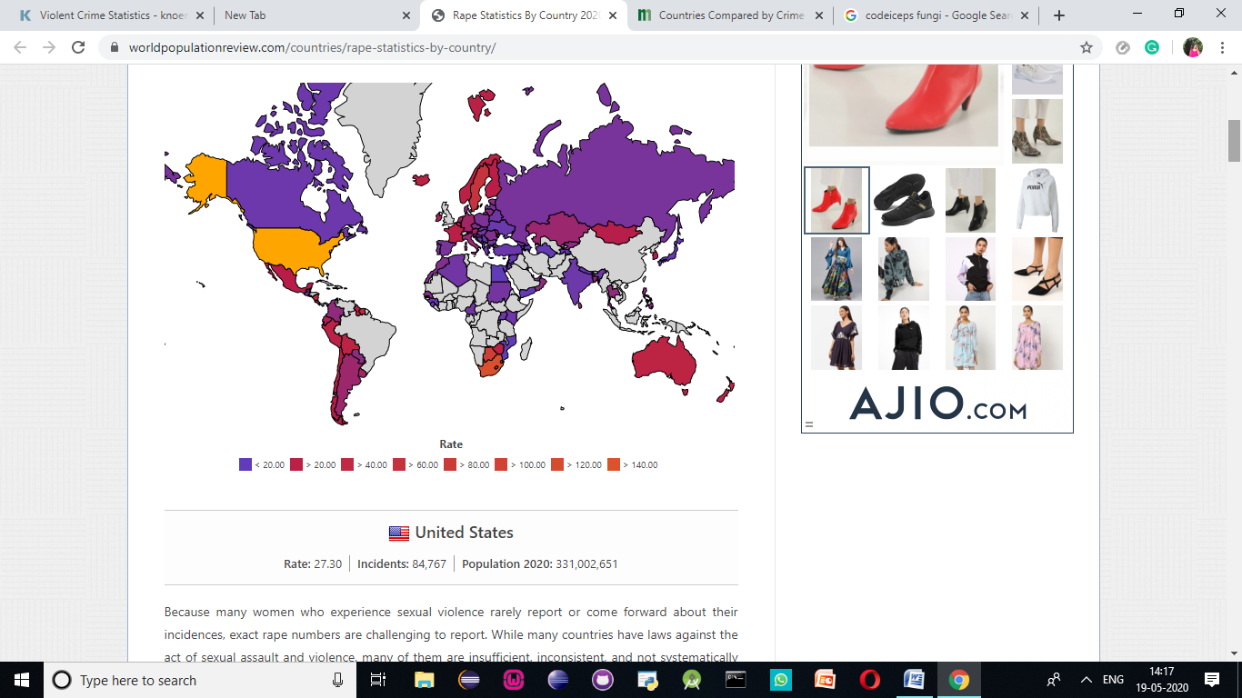

**Figure 3**

**INTERESTING OBSERVATIONS ABOUT CRIME AND RAPE RATES**

* South Africa has had the highest rape rate since 2004.
* Sweden ranked first for rape rate amongst European Union in 2010.
* All of the top 3 countries by rape rate are Sub-Saharan African.
* Belgium ranked first for rape rate amongst NATO countries in 2010.
* Australia ranked second for rape rate amongst High income OECD countries in 2010.
* All of the top 6 countries by rape rate are Christian.
* United States ranked third for rape rate amongst Cold countries in 2010.
* France ranked second for rape rate amongst Eurozone in 2009.
* Iceland ranked third for rape rate amongst Europe in 2009.
* Moldova ranked first for rape rate amongst Eastern Europe in 2010.

**Chapter 3**

**Design and Methodology**

* 1. **METHODOLOGY:**

Data analytics is the science of analyzing raw data in order to make conclusions about that information. Many of the techniques and processes of data analytics have been automated into mechanical processes and algorithms that work over raw data for human consumption.

Data analytics techniques can reveal trends and metrics that would otherwise be lost in the mass of information. This information can then be used to optimize processes to increase the overall efficiency of a business or system.

The process involved in data analysis involves several different steps:

1. The first step is to determine the data requirements or how the data is grouped. Data may be separated by age, demographic, income, or gender. Data values may be numerical or be divided by category.
2. The second step in data analytics is the process of collecting it. This can be done through a variety of sources such as computers, online sources, cameras, environmental sources, or through personnel.
3. Once the data is collected, it must be organized so it can be analyzed. Organization may take place on a spreadsheet or other form of software that can take statistical data.
4. The data is then cleaned up before analysis. This means it is scrubbed and checked to ensure there is no duplication or error, and that it is not incomplete. This step helps correct any errors before it goes on to a data analyst to be analyzed.
5. Predictive analysis must be done on cleaned data to get the most accurate results.

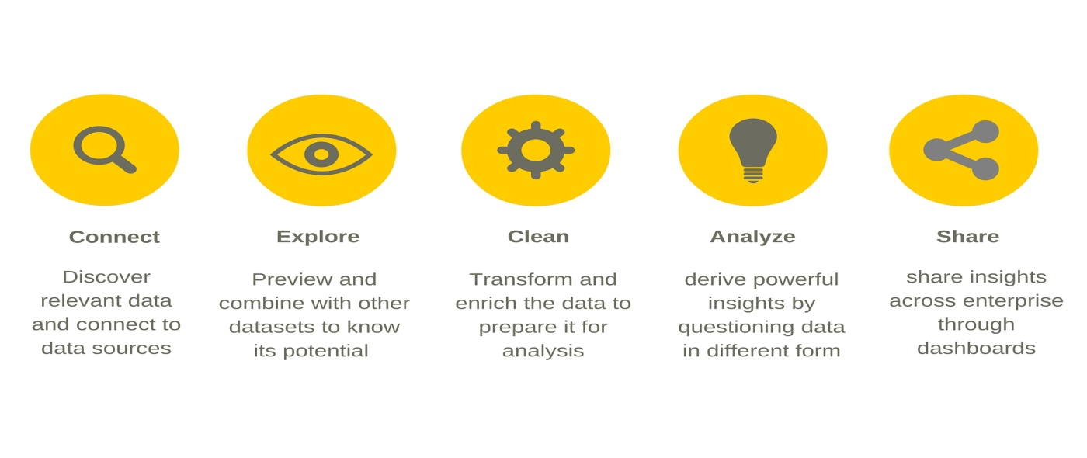

**Figure 4**

**3.2 DATASET SELECTION**

For this research we have used six datasets. All are from Open Government Data (OGD) Platform India (data.gov.in).

1. Crime against Women during 2001-2012
2. World crime against women statistics
3. District-wise crimes committed against Women during 2001-2012
4. Age and sex wise persons arrested under crime against women during 2012
5. Persons arrested under crime against Women during 2001-2012.
6. USA rape statistics 2000-2015
7. Json files for world maps

Datasets 1 is contributed by Ministry of Home Affairs, Department of States, National Crime Records Bureau (NCRB). Datasets 3 and 5 are contributed by Ministry of Home Affairs,

Department of States, National Crime Records Bureau (NCRB).

**3.3 EXPLORATORY DATA ANALYSIS (EDA)**

Exploratory Data Analysis (EDA) is an approach/philosophy for data analysis that employs a variety of techniques (mostly graphical) to

* Maximize insight into a data set
* Uncover underlying structure
* Extract important variables
* Detect outliers and anomalies
* Test underlying assumptions
* Develop parsimonious models
* Determine optimal factor settings.

Most EDA techniques are graphical in nature with a few quantitative techniques. The reason for the heavy reliance on graphics is that by its very nature the main role of EDA is to open-mindedly explore, and graphics gives the analysts unparalleled power to do so, enticing the data to reveal its structural secrets, and being always ready to gain some new, often unsuspected, insight into the data.

**3.4 DATA CLEANING**

Data cleaning is the process of preparing data for analysis by removing or modifying data that is incorrect, incomplete, irrelevant, duplicated, or improperly formatted. This data is usually not necessary or helpful when it comes to analyzing data because it may hinder the process or provide inaccurate results. The nulls of the dataset will be removed so that we may get accurate predictions. Predictive analysis must be done on cleaned data to get the most accurate results.

**3.5 PREDICTIVE ANALYSIS**

Predictive analytics is the practice of extracting information from existing data sets in order to determine patterns and predict future outcomes and trends. Since the data that we have are labelled and structured, we have decided to use linear regression prediction methods to calculate the future crime rates against women with time.

**3.6 LINEAR REGRESSION USED FOR PREDICTIVE ANALYSIS**

Data analysts often use a linear relationship to predict the (average) numerical value of Y for a given value of X using a straight line (called the regression line). If you know the slope and the y-intercept of that regression line, then you can plug in a value for X and predict the average value for Y. In other words, you predict (the average) Y from X.

Simple linear regression makes use of the formula y= mx +c. By calculating the values of the slope and Y-intercept, we can predict the value of the dependent variable using the known values of the independent variable.

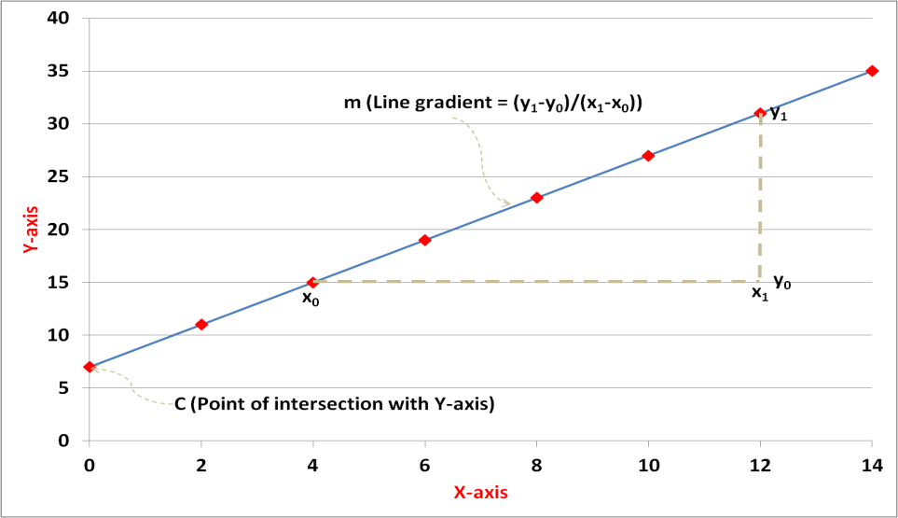

**Figure 5**

**3.7 K MEANS**

Kmeans algorithm is an iterative algorithm that tries to partition the dataset into K pre-defined distinct non-overlapping subgroups (clusters) where each data point belongs to only one group. It tries to make the intra-cluster data points as similar as possible while also keeping the clusters as different (far) as possible. It assigns data points to a cluster such that the sum of the squared distance between the data points and the cluster’s centroid (arithmetic mean of all the data points that belong to that cluster) is at the minimum. The less variation we have within clusters, the more homogeneous (similar) the data points are within the same cluster.

The way k means algorithm works is as follows:

* Specify number of clusters K.
* Initialize centroids by first shuffling the dataset and then randomly selecting K data points for the centroids without replacement.
* Keep iterating until there is no change to the centroids. i.e assignment of data points to clusters isn’t changing.
* Compute the sum of the squared distance between data points and all centroids.
* Assign each data point to the closest cluster (centroid).
* Compute the centroids for the clusters by taking the average of the all data points that belong to each cluster.

**3.8 ARCHITECTURE AND DESIGN**

**3.8.1 FLOWCHART:**

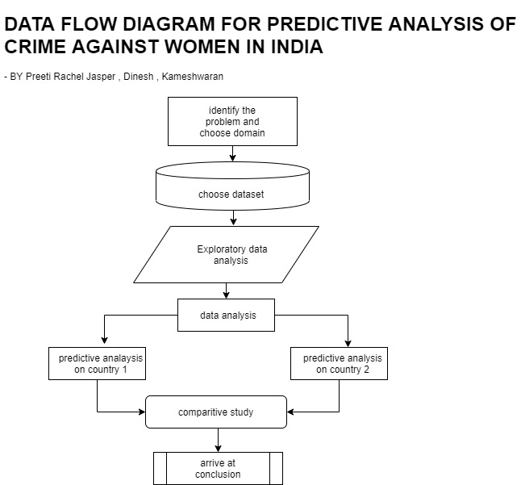

**Figure 6**

**3.8.2 USE CASE DIAGRAM**

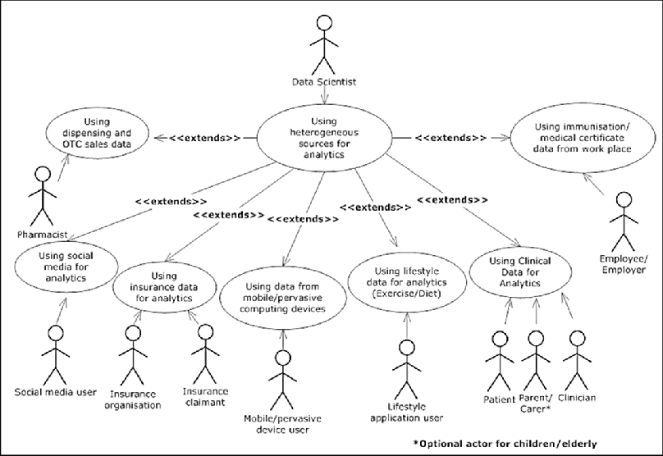

**Figure 7**

**3.8.3 CLASS DIAGRAM**

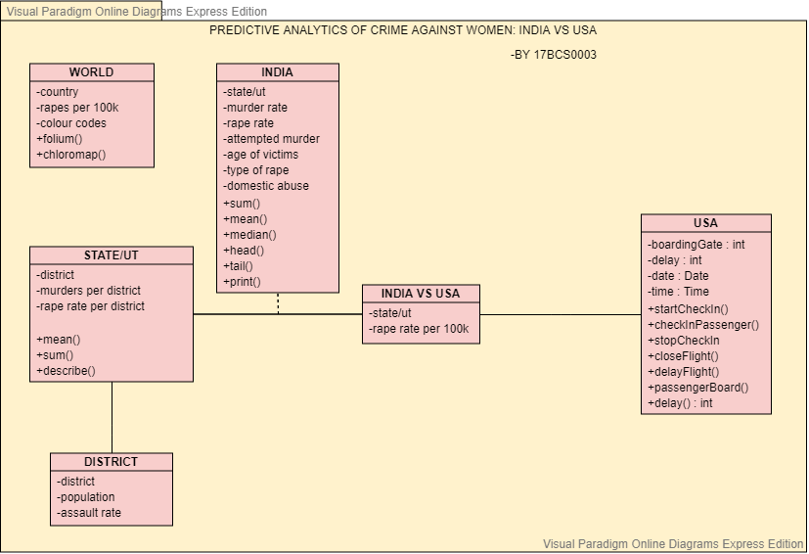

**Figure 8**

**3.8.4 DATA FLOW DIAGRAM**

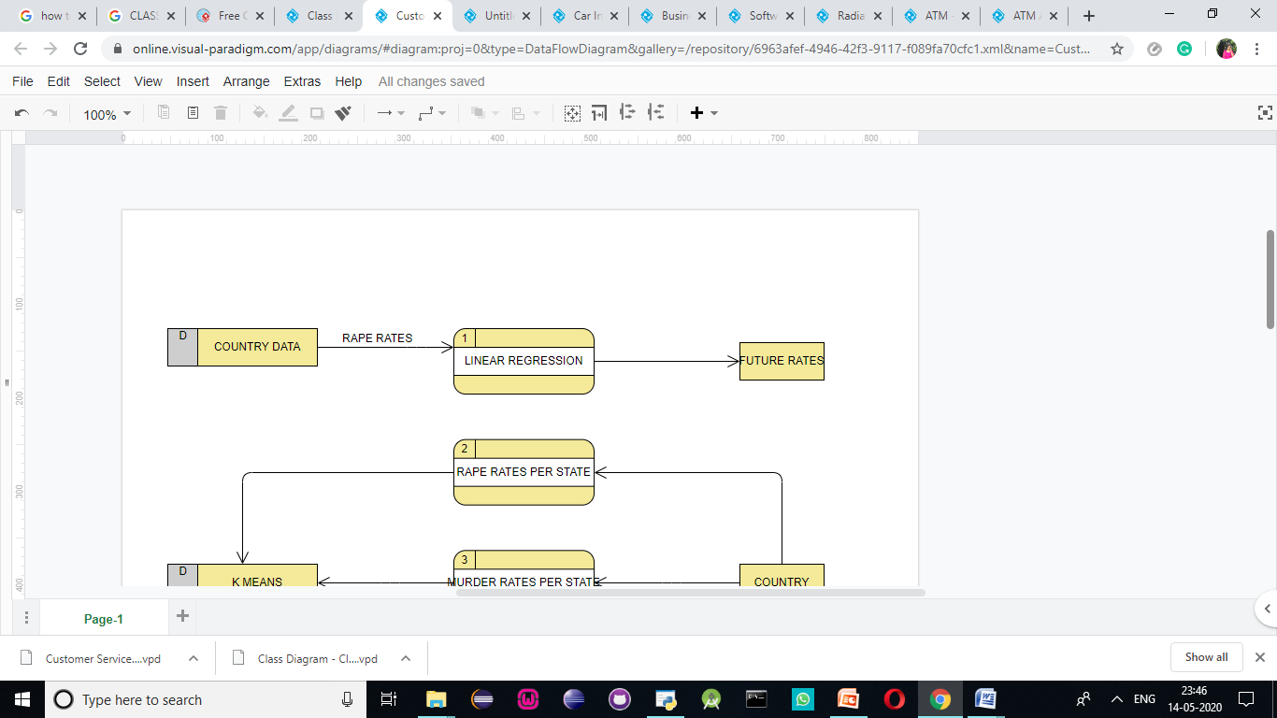

**Figure 9**

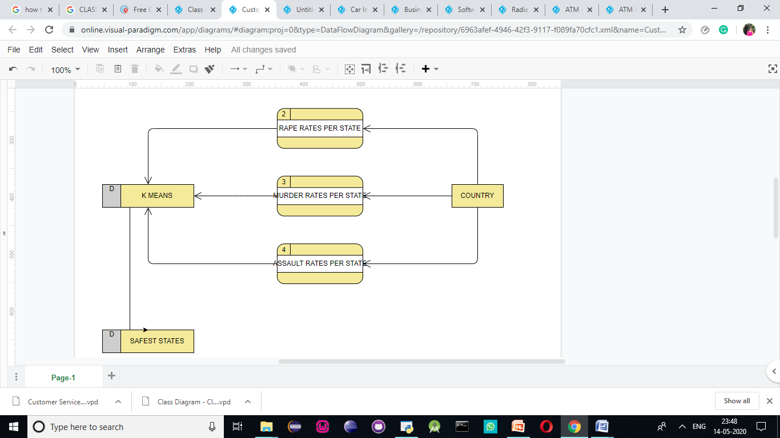

**Figure 10**

**Chapter 4**

**Implementation**

**4.1 INDIA**

India is considered to be a Third World country and is also a developing country today. India has a high poverty rate, corruption, a very prevalent caste system, and other significant issues that people say are causes for violence and inequality in India. According to the National Crime Records Bureau of India, a crime against women is committed every 3 minutes, and the rate of crime showed an increase of approximately 50% from the years 2011- 2015 ( in four years). However, we must understand that India has a population of approximately 136 crores. This has not been taken into account by most studies done. Here, we aim to find the underlying issues behind rape and sexual abuse in India as well as deep dive into the condition of each state. We will also compare India, a third world country with a first world country to understand how development and economy sets us apart. Meanwhile, we hope to bust some of the myths perpetuated about India in the world by faulty statistical studies.

Our first step is to study the dataset provided to better understand the study. The data collected is first imported to the notebook. Using the pandas library the csv file is imported and ready for use. Now, by using df.head() function, by default the first five rows can be seen.

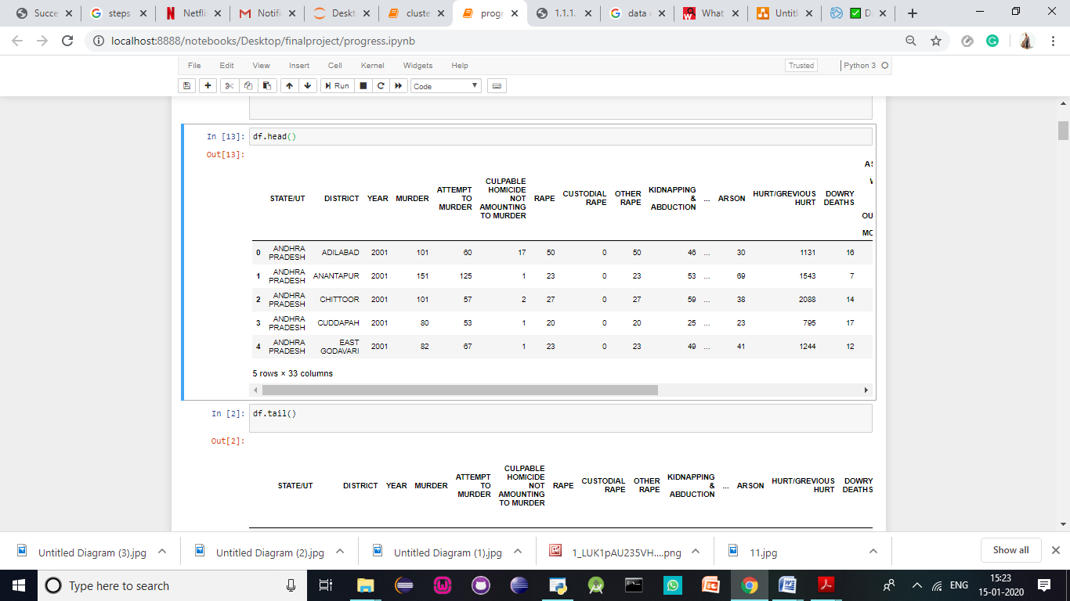

**Table 1**

Now, by using the df.tail() function the last five rows are seen. These functions are used to make sure the csv file has been imported correctly.

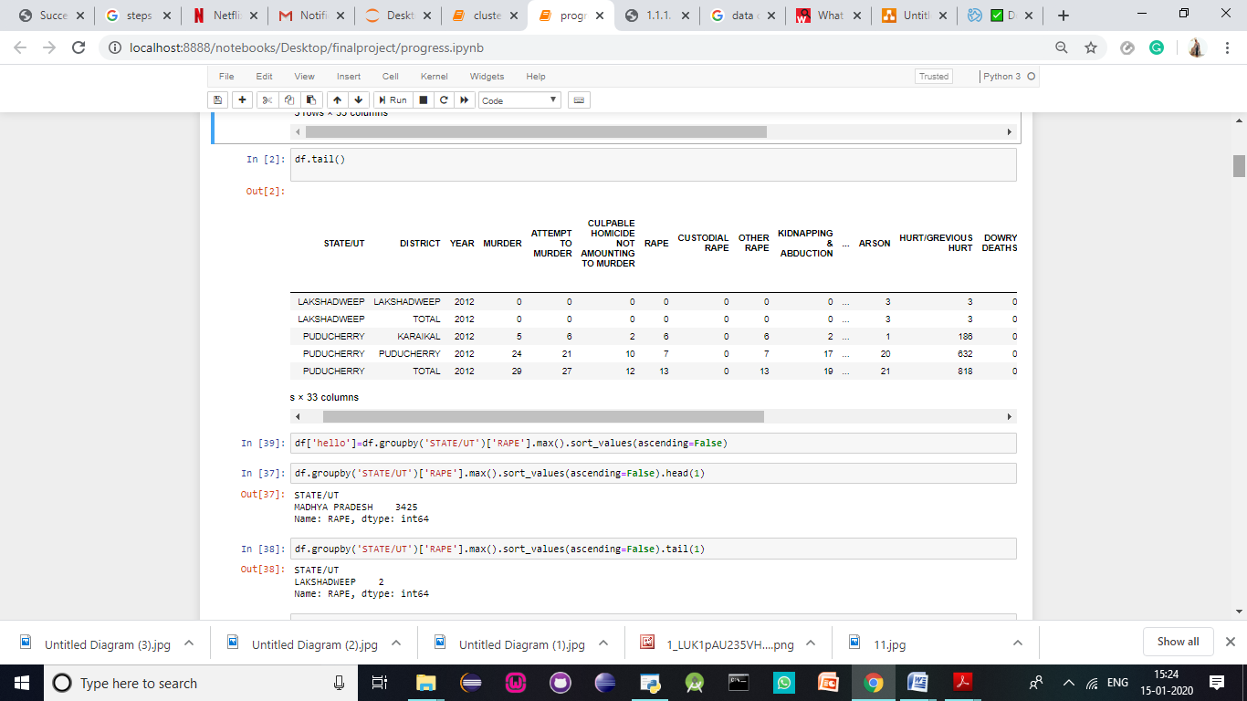

**Table 2**

In India, Madhya Pradesh is infamous for the large number of sexual assaults caused. This should reflect in our datasets to make sure the dataset provided is correct. Madhya Pradesh leads over all other states with a colossal amount of 3425 rape assaults. Now, while performing EDA, we find the state which has the most number of reported sexual assaults against women below.

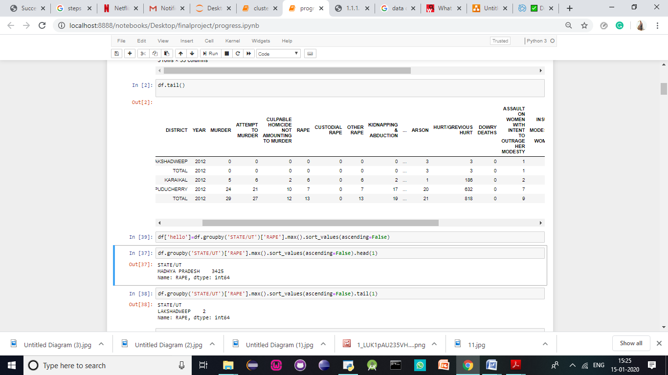

**Table 3**

However, the Union Territoty Lakshadweep seems to have the lowest reporting of rape consecutively. Now,we find the state which has the lowest number of sexual assaults.

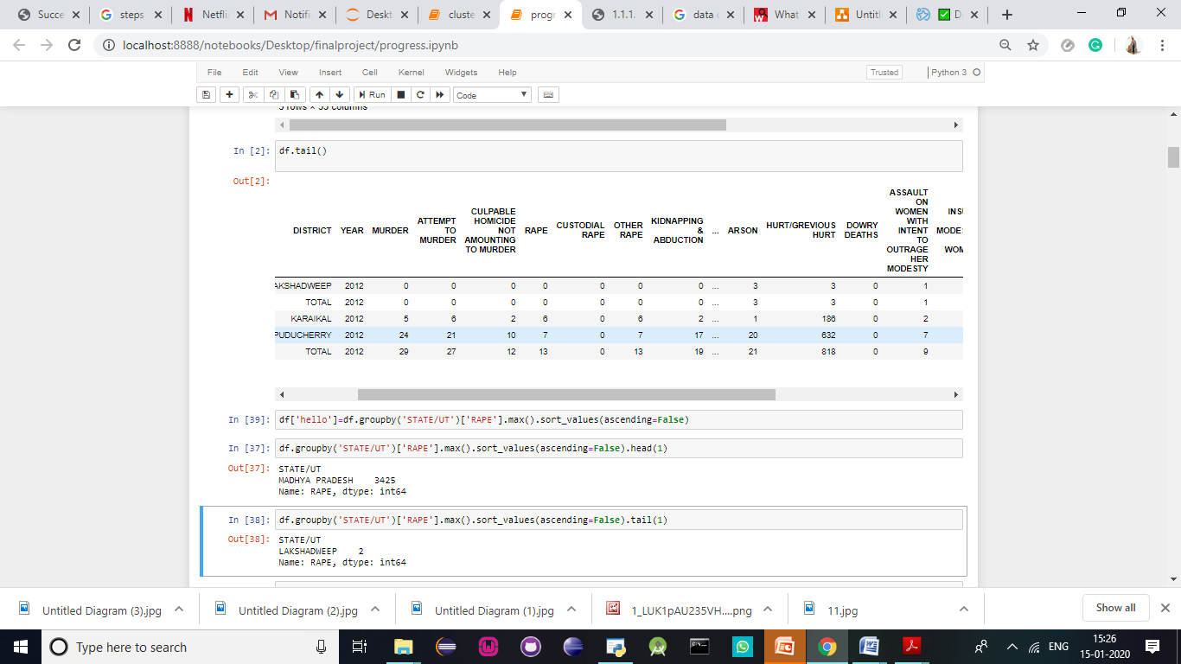

**Table 4**

The null values are replaced with ‘’ and then the sum of null values is calculated to find the sum of null values.

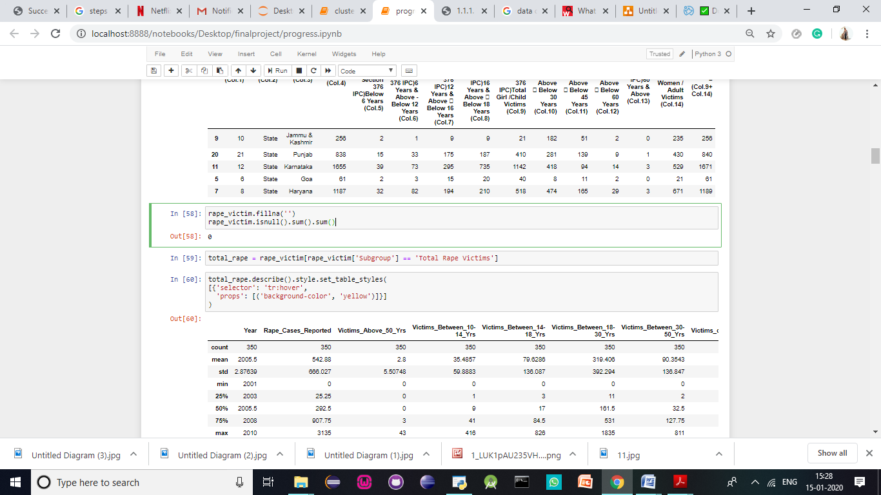

**Table 5**

Correlogram of the input variables is found to represent graphically, the correlation each variable has on the other. The lighter shades from the graph show higher correlation. It is very interesting to note that RAPE and ASSAULT AGAINST A WOMAN WITH THE INTENT TO OUTRAGE HER MODESTY has one of the highest levels of correlation. We will further prove this through mathematical means while conducting clustering.

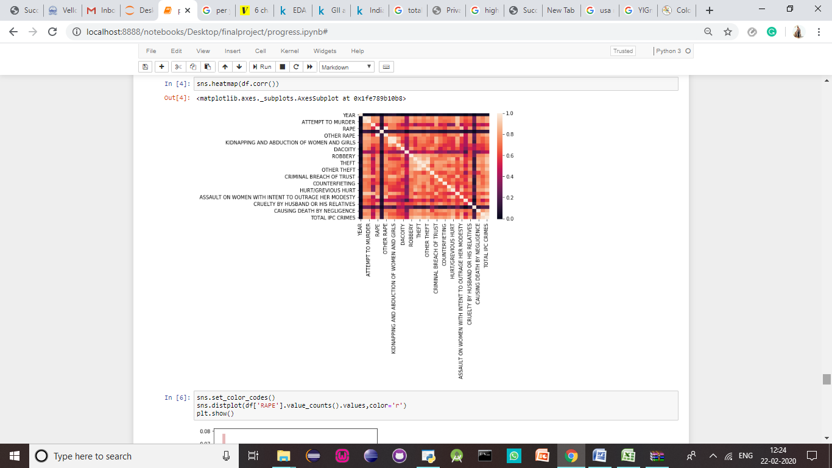

**Figure 11**

In this box plot we see that over the decade, the intensity of rape cases increases almost steadily. This is very interesting and alarming to note because as the country continues to develop, the conditions of women are alarmingly decreasing.

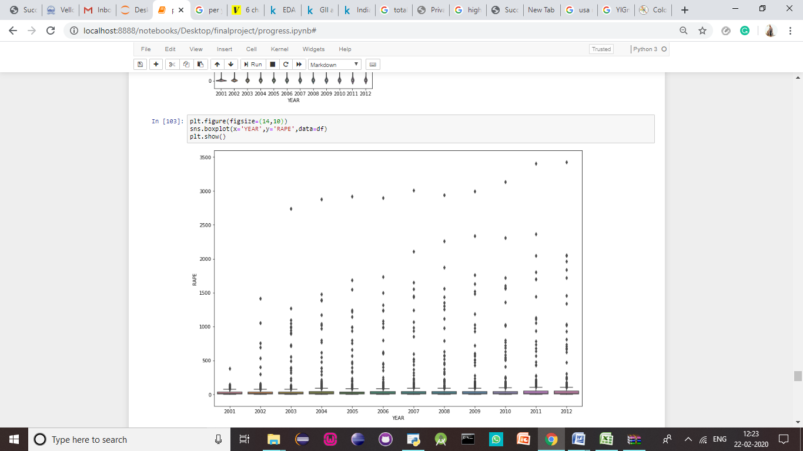

**Figure 12**

**4.2 EXPLORATORY DATA ANALYSIS (EDA)**

Over the decade, the condition of women has slowly declined. With a steep and almosr steady climb, the number of rapes in India every year is at an all time low .Now, we use python to find and visualize the line graph showing the condition of the country over the past decade. One can see a considerable raise in the number of crimes reported over the decade. From the graph, we can see that over the decade the numbers have gone from approximately 15000 to 22000.

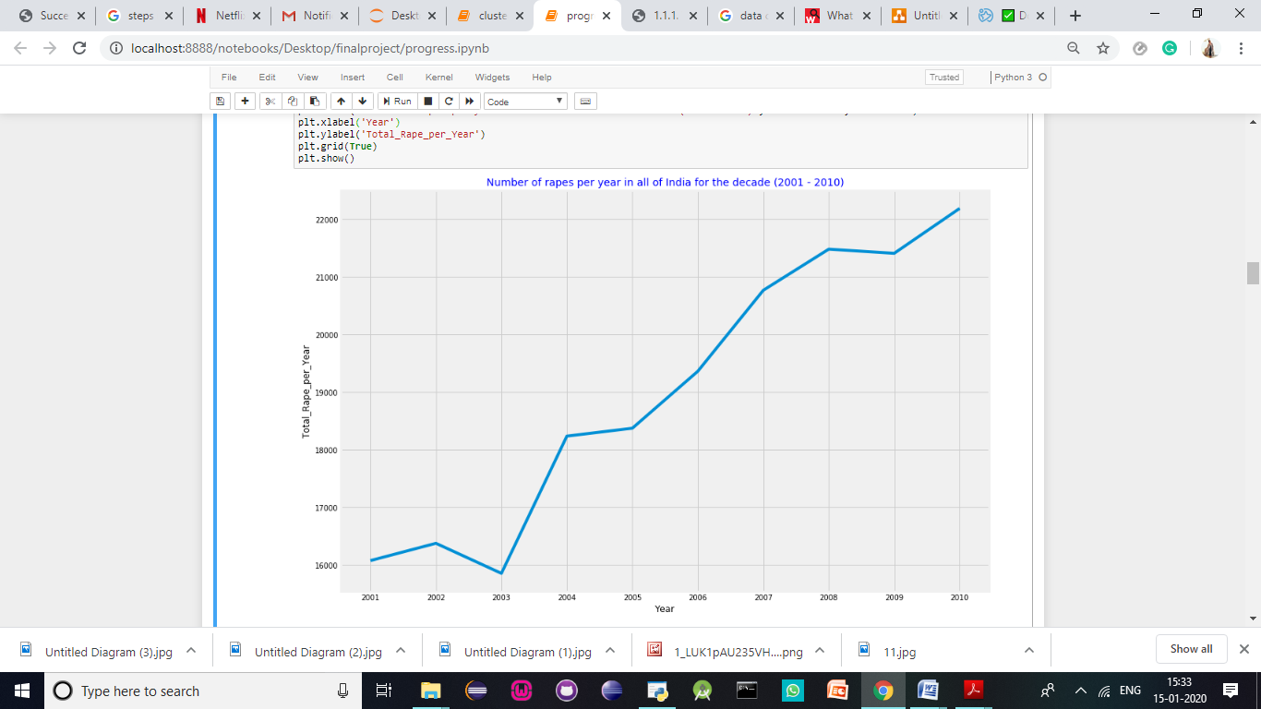

**Figure 13**

The folium library is used to visualize the crime data against women per capita. This shows that the per capita rates in India are low. This supports the hypothesis that the population spurt in India over the decade could be the reason. The code is written the visualise the .json file for better understanding.

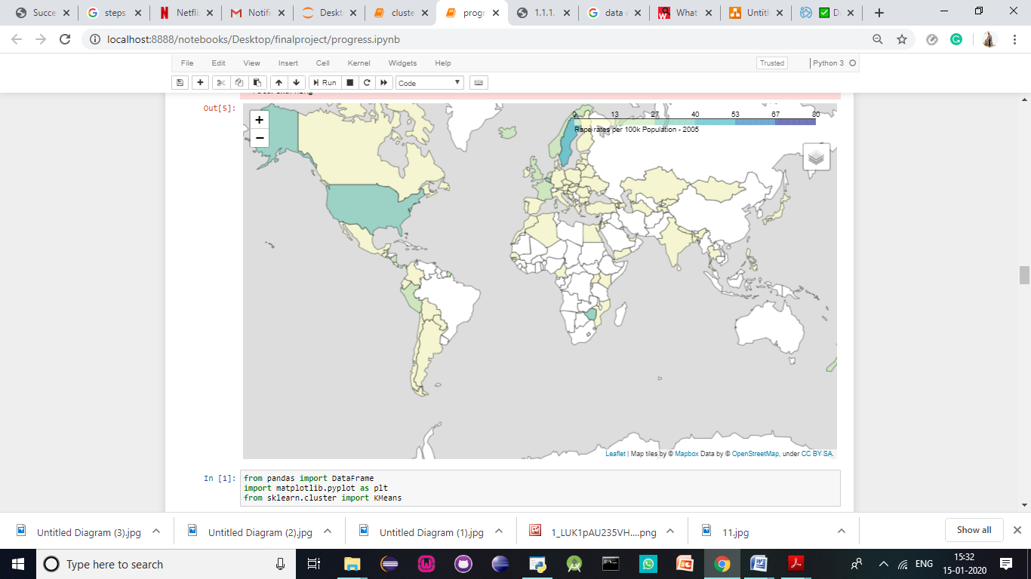

**Figure 14**

However, even though the number of assaults against women has increased over the decade. Many rumours spread about the state of our country seem to be false. When the number of rapes have been calculated per capita , we can see that India has very low rates of sexual assault in the world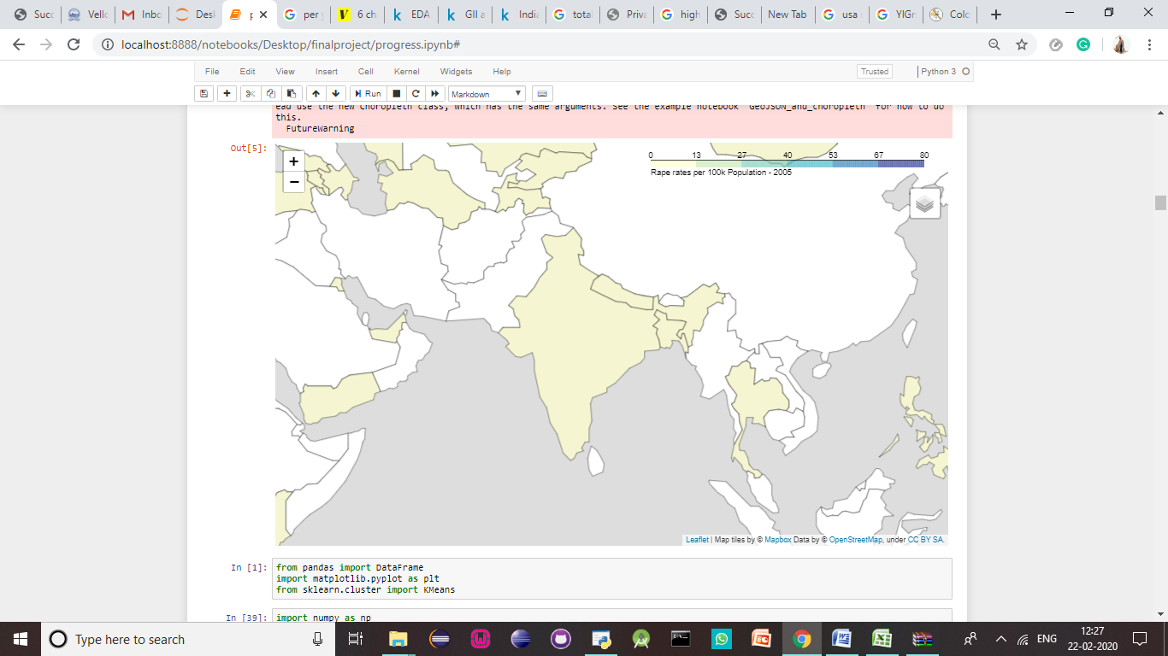

**Figure 15**

Now the data is cleaned and normalized. From the csv file, the total data is deleted and then the data is normalized. The code for normalization is done using the MinMaxScaler. The df_normalized attributes are seen below.

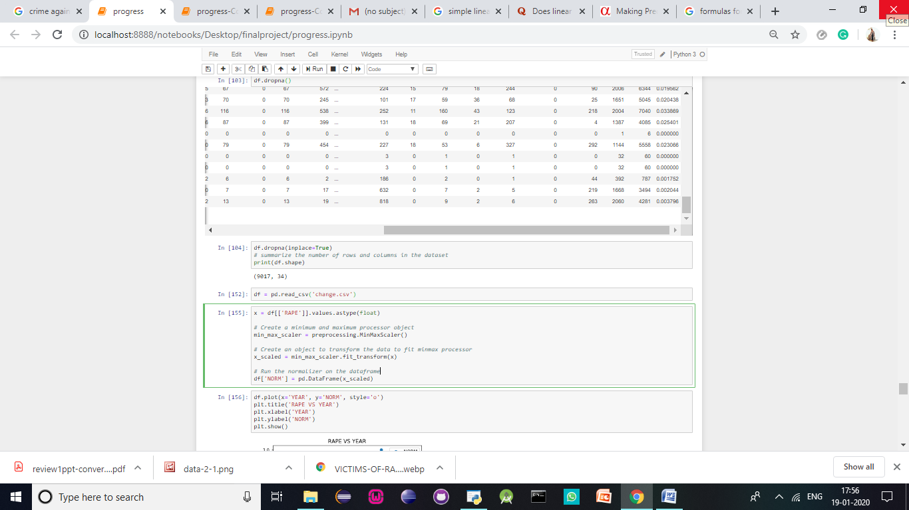

**Figure 16**

From conducting Exploratory data analysis we have better understood the past data. To summarise, let’s look at the various interesting findings we have made.

* Firstly, we find that the state with the highest number of rapes is Madhya Pradesh with an approximate number of 3000
* The one with the lowest number of rapes is Lakshadweep with the approximate value of two per year.
* It is important to note that when you calculate the mean number of rape cases in India, you can see that over the decade it has been approximately ~50
* We then wanted to know the age group for women mostly targeted by rapists and we have found that the women who are at the prime of their age and are usually in colleges or work targeted. The average of age group targeted is from the age of 18-30.
* From the correlogram , you can see that the highest correlation exists between rapes and assault against a woman with the intent to outrage her modesty. This can lead one to believe that rape is conducted with the intent to shame the women or to cause question of her modesty.
* From the world map, you can notice that the number of rapes per capita in India is quite low. This is very contradictory to popular belief that women are not at all safe in India. However, this can also be due to a number of reasons, the main one being that the many number of rapes do not get justice or in many cases, do not even get reported in India due to the various cultural and religious constraints and judgements cast on a woman subject to such abuse.

**4.3 LINEAR REGRESSION (INDIA)**

If you establish at least a moderate correlation between *X*and *Y* through both a correlation coefficient and a scatter plot, then you know they have some type of linear relationship. In our case, we have a time series. We want to predict the number of rapes that might take place in the future years. Given that we understand the data set, we can arrive at a reasonable number close to the average of rapes over the decades in various states all over India. First lets import all the libraries required for carrying out linear regression effectively.

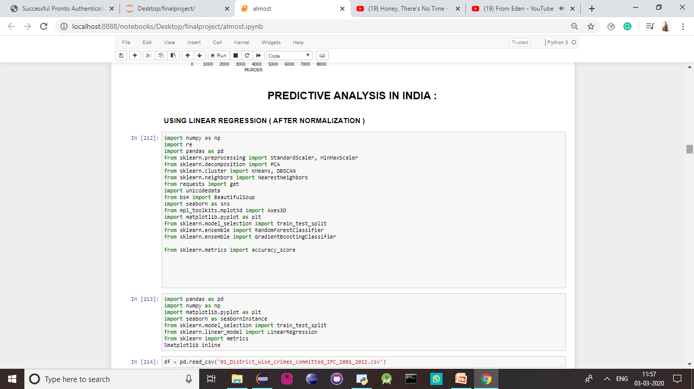

**Figure 17**

The describe() function helps us understand the dataset we are going to be working on a little better. We understand that the average number of rapes in India is close to 40-50 in districts. So, we must keep this in mind while calculating the result and then testing the values to see if they are accurate.

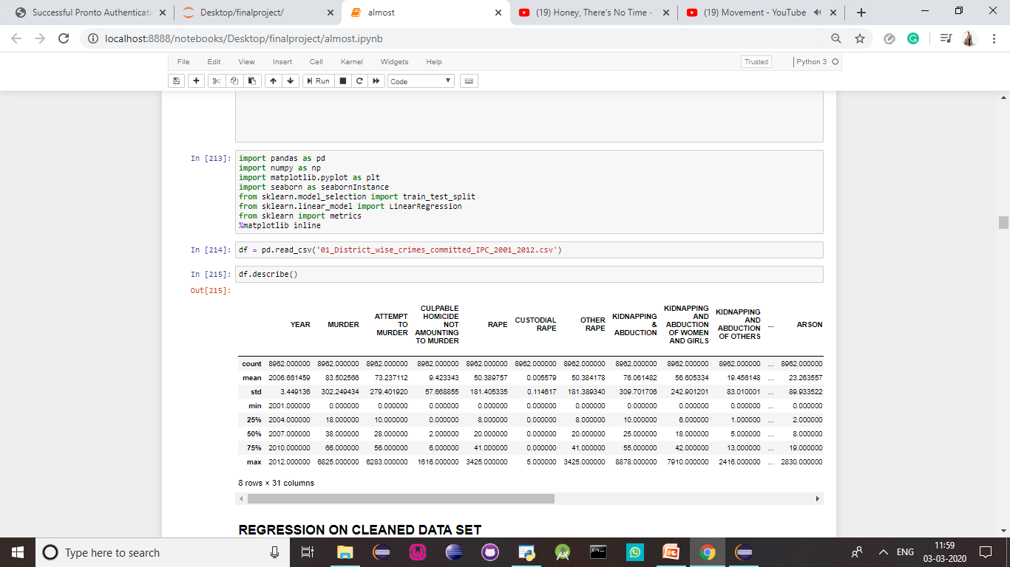

**Table 6**

The scatter plot must first be executed for the two variables we are going to use for the linear regression . From the linear regression, we see that the intensity of rapes averages around 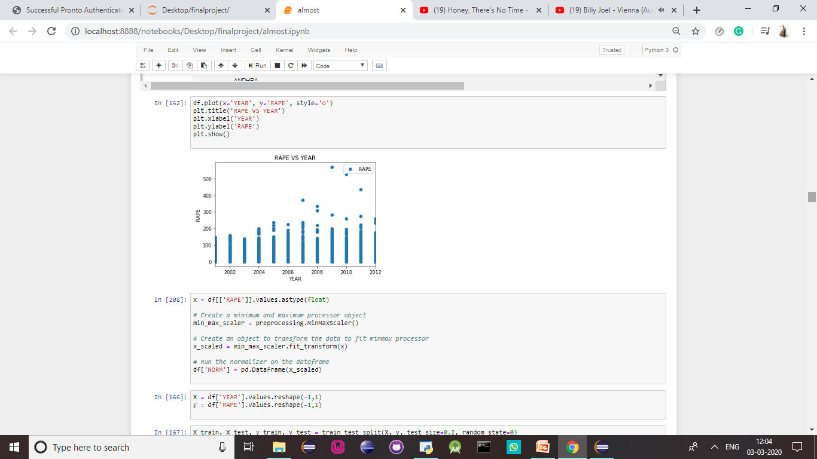

**Figure 18**

Now let us perform normalization so that we can perform result analysis. After normalization, let us look at the scatter plot.

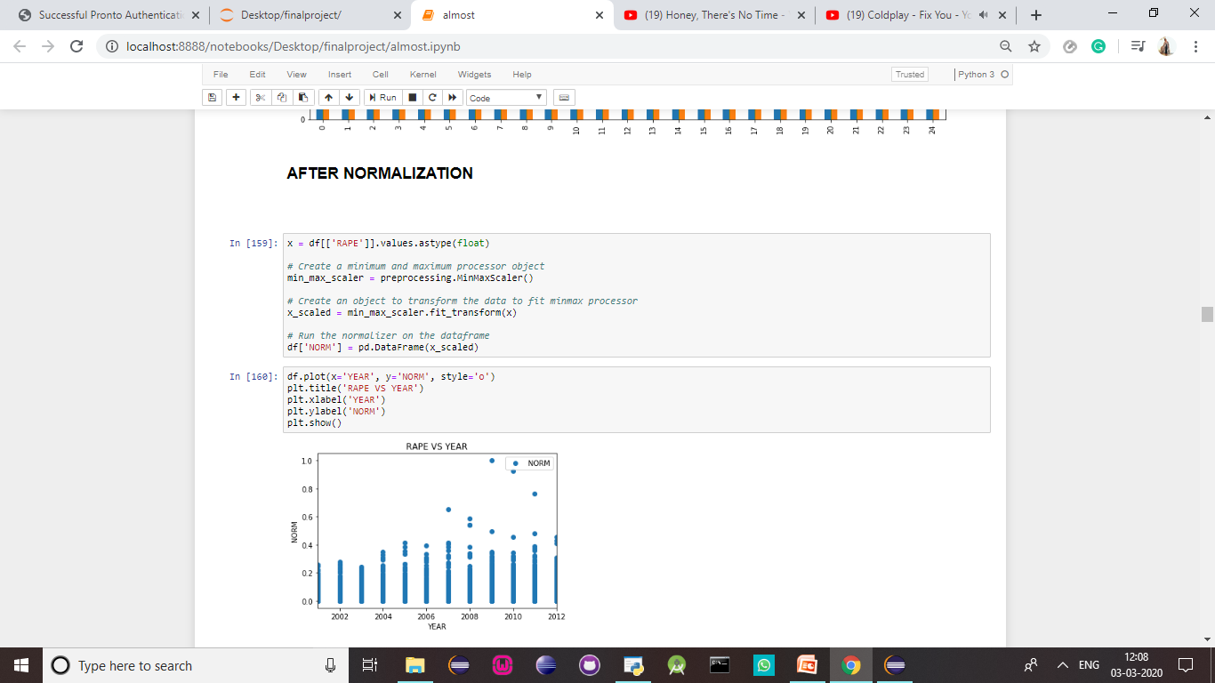

**Figure 19**

A distribution plot displays a distribution and range of a set of numeric values plotted against a dimension. You can display this chart in three different ways, you can just have the value points displayed showing the distribution, or you can display the bounding box which shows the range or use a combination of both. In the distribution plot shown below, you can see there a range and distribution of the rape values displayed for 0.0- 1.0. Each range and distribution box show how data values for a product group is distributed over the average rape rates per district.

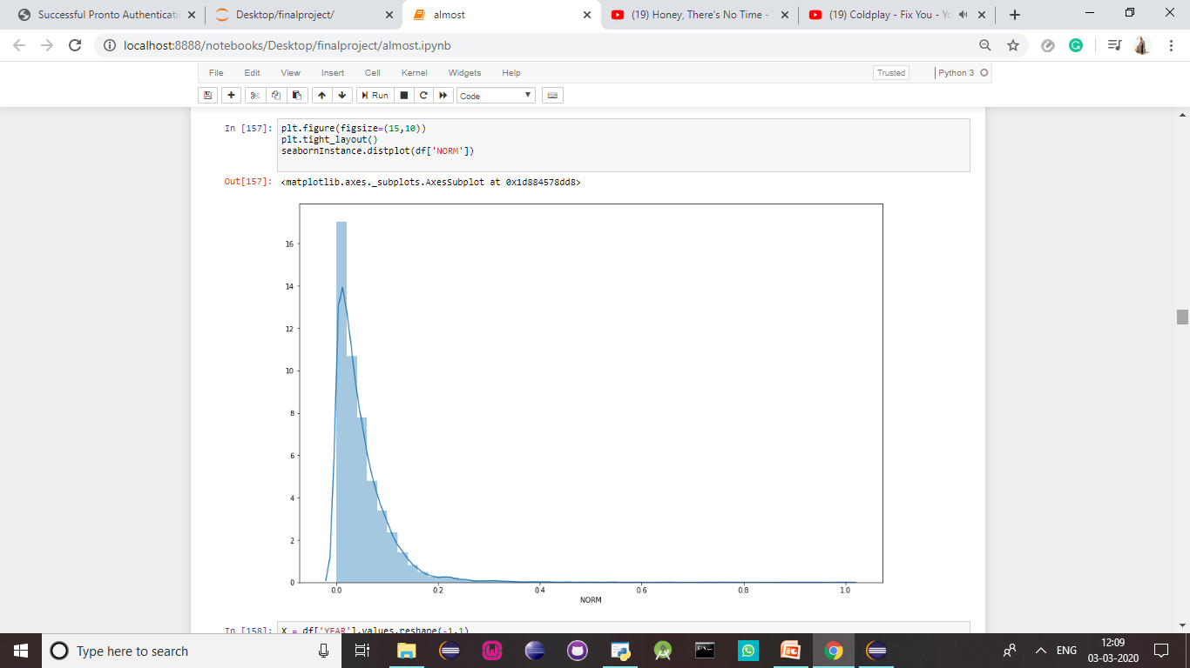

**Figure 20**

In statistics, the actual value is the value that is obtained by observation or by measuring the available data. It is also called the observed value. The predicted value is the value of the variable predicted based on the regression analysis. The difference between the actual value or observed value and the predicted value is called the residual in regression analysis.  
  
The difference between the actual and the predicted value is the residual which is defined as:  
  
  
  
Here, *e* is the residual, *y* is the observed or actual value and  is the predicted value.  
Each actual value has a predicted value and hence each data point has one residual. If the difference between the actual value and the predicted value is positive, then the data points are above the regression line. If the difference between the actual value and the predicted value is negative, then the data points are below the regression line. If the difference is zero, then that data points lie on the regression line. If the line of best fit is the best fit then the sum of the difference between the actual value and the predicted values is always zero. The residuals play a vital role to validate the obtained regression model. Residuals are represented graphically by means of a residual plot. If the data points on the residual plot are spread around the horizontal axis, it indicates the appropriateness of a linear regression model. If it is not spread around the horizontal axis, it indicates the appropriateness of non-linear regression model.

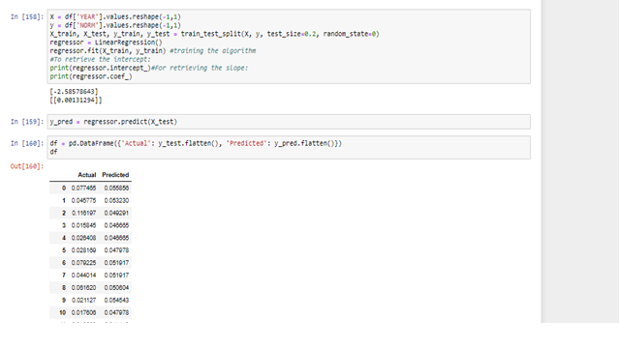

**Figure 21**



**Figure 22**

From the above calculations we can see that the y intercept has a value of -2.585 and the slope has a value of 0.0001. When we apply this to the equation, y=mx+c, to find the value of the dependable variable y. This will help us predict the rape rates per state for the future years. This can help us understand and better prepare for the future law enforcement.

Let us calculate the predicted value of the average value of rapes per state in India. Once, this is done the value of the predicted variable is ~34.7 per state for a single year.

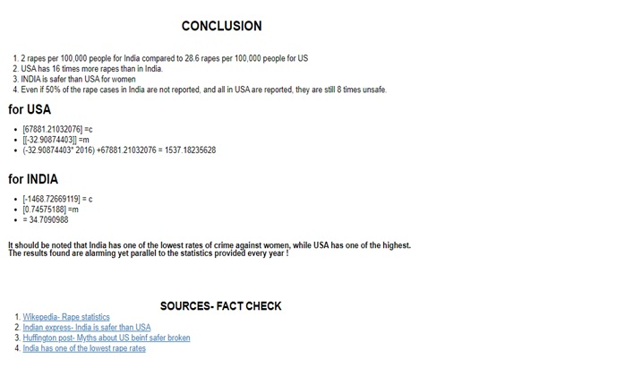

This proves the point that the per capita rates of rape in India is one of the lowest rates in the world.

**4.4 UNDERSTANDING USA**

Modern connotation of the word ‘first world’ ,which USA is both politically and in terms of privilege does refer to the privileged people, who live in a stable economy by virtue of a stable political system, where people have food, shelter, clothing, transportation, healthcare and an infrastructure in place, and yet they are complaining and whining about little small things not aligning their ways and are oblivious to the real issues that people in the world face, of walking long distances for water, of having children that have stunted growth because they can’t feed them baby food and they have osteoporosis and anorexia because of lack of nutrition, gathering in a large open space to watch a movie or never be entertained, or eat meat only on a festive day once a year, something that is hard to imagine for some of the western people.

However,on average, there are 433,648 victims (age 12 or older) of rape and sexual assault each year in the United States. Ages 12-34 are the highest risk years for rape and sexual assault. While those age 65 and older are 92% less likely than 12-24 year olds to be a victim of rape or sexual assault, and 83% less likely than 25-49 year olds. Millions of women in the United States have experienced rape. As of 1998, an estimated 17.7 million American women had been victims of attempted or completed rape. Young women are especially at risk. 82% of all juvenile victims are female. 90% of adult rape victims are female. Females ages 16-19 are 4 times more likely than the general population to be victims of rape, attempted rape, or sexual assault. Women ages 18-24 who are college students are 3 times more likely than women in general to experience sexual violence. Females of the same age who are not enrolled in college are 4 times more likely.

**4.5 EXPLORATORY DATA ANALYSIS (USA)**

Our first step is to study the dataset provided to better understand the study. The data collected is first imported to the notebook. Using the pandas library the csv file is imported and ready for use. Now, by using df.head() function, by default the first five rows can be seen.

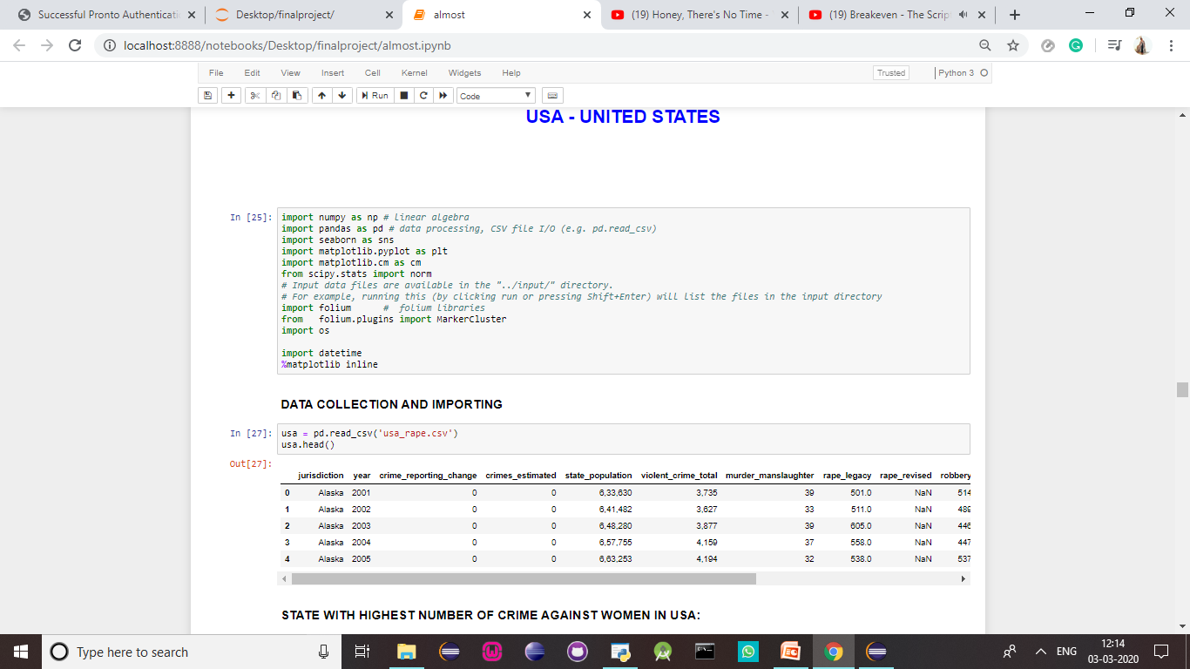

**Table 7**

In 2018, California had the highest number of forcible rape cases in the United States, with 15,505 reported rapes. Vermont had the lowest number of reported forcible rape cases at 243.  
It is perhaps unsurprising that California had the highest number of reported rapes in the United States in 2018, as California is the [state with the highest population](https://www.statista.com/statistics/206097/resident-population-in-california/). When looking at the [rape rate](https://www.statista.com/statistics/232563/forcible-rape-rate-in-the-us-by-state/), or the number of rapes per 100,000 of the population, a very different picture is painted: Alaska was the state with the highest rape rate in the country in 2017, with California ranking as 35th in the nation.

. 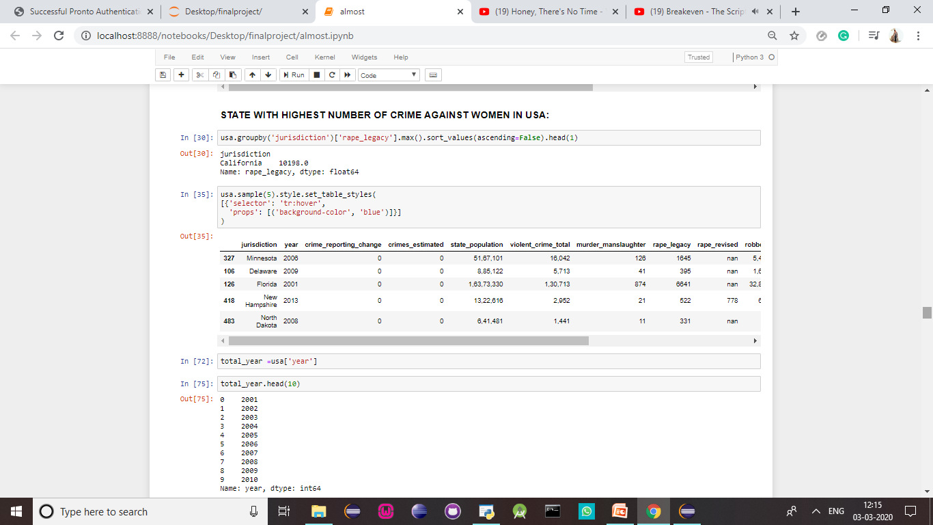

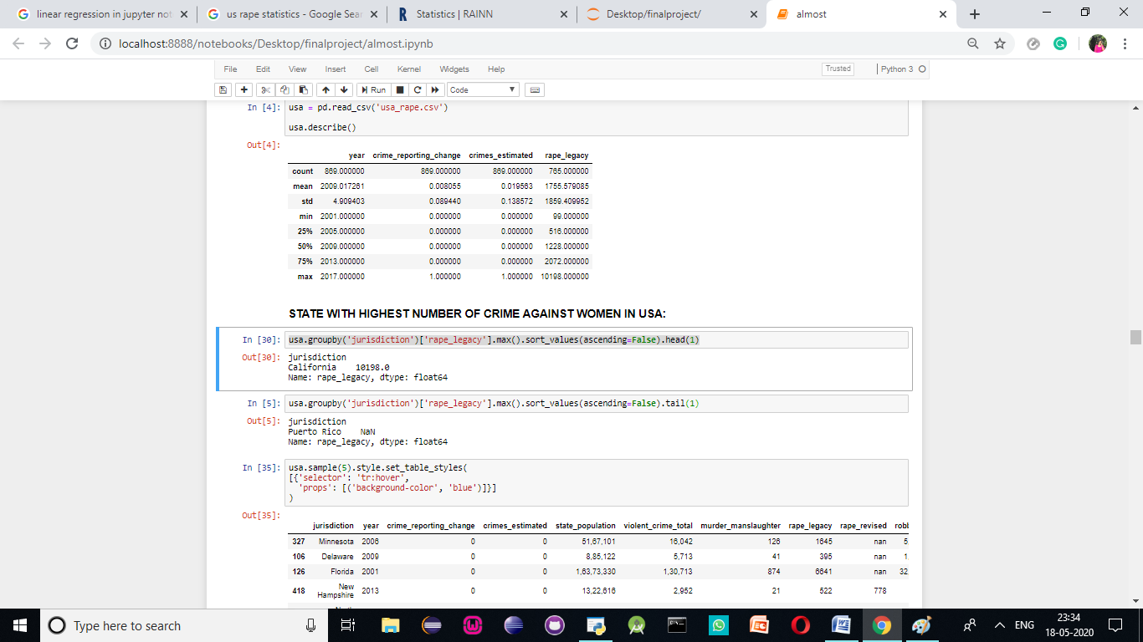

**Table 8**

Rape prevalence among women in the U.S. (the percentage of women who experienced rape at least once in their lifetime so far) is in the range of 15–20% according to different studies (National Violence against Women survey, 1995, found 17.6% prevalence rate.A 2007 national study for the Department of Justice on rape found 18% prevalence rate. According to a March 2013 report from the U.S. Department of Justice's Bureau of Justice Statistics, from 1995 to 2010, the estimated annual rate of female rape or sexual assault declined 58%, from 5.0 victimizations per 1,000 females age 12 or older to 2.1 per 1,000.

The 2018 Uniform Crime Report (UCR), which measures rapes that are known to police, estimated that there were 127,258 rapes reported to law enforcement in 2018. However, in 2016 National Crime Victimization Survey (NCVS), which measures sexual assaults and rapes that may not have been reported to the police, estimated that there were 431,840 incidents of rape or sexual assault in 2015.

This is the graph showing you the number of crimes against women in USA over the decade:

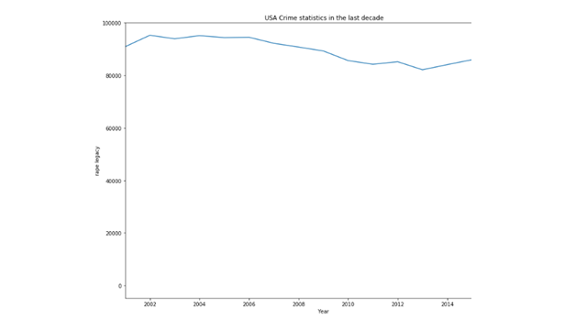

**Figure 23**

In 2018, the rate of forcible rapes in the United States stood at 30.9 per 100,000 inhabitants. While this figure is about the same as it was in 2007, when the rate was 30.6, it has decreased from 1990, when there were 41.2 forcible rapes per 100,000 inhabitants.

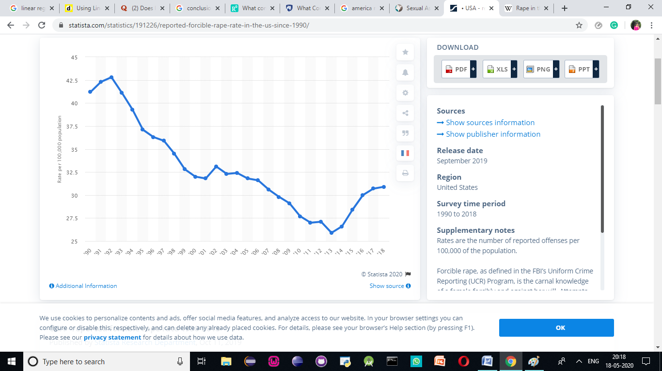

**Figure 24**

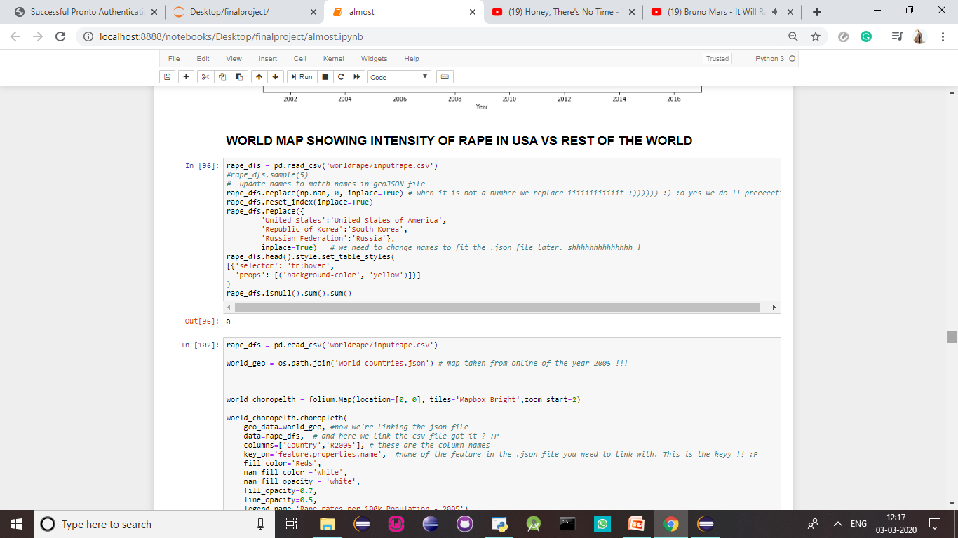

**Figure 25**

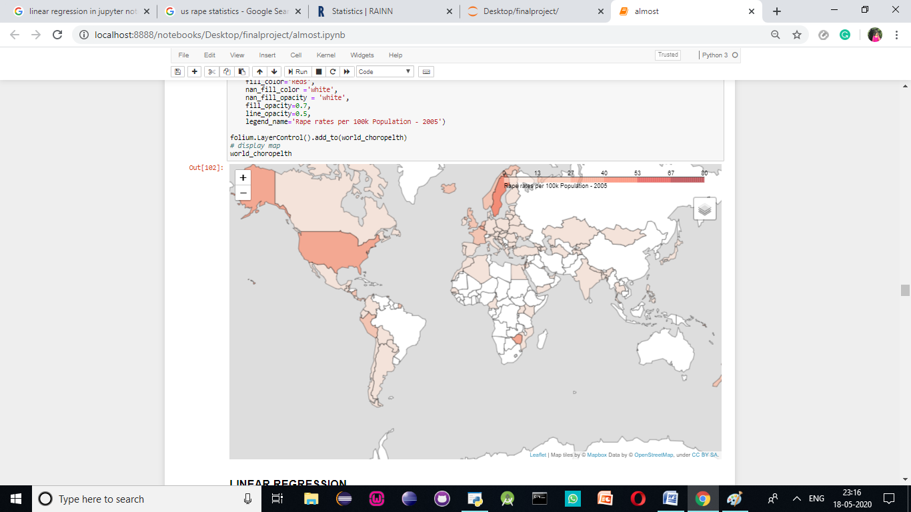

**Figure 26**

We can see that USA has one of the highest numbers of rapes in the world:

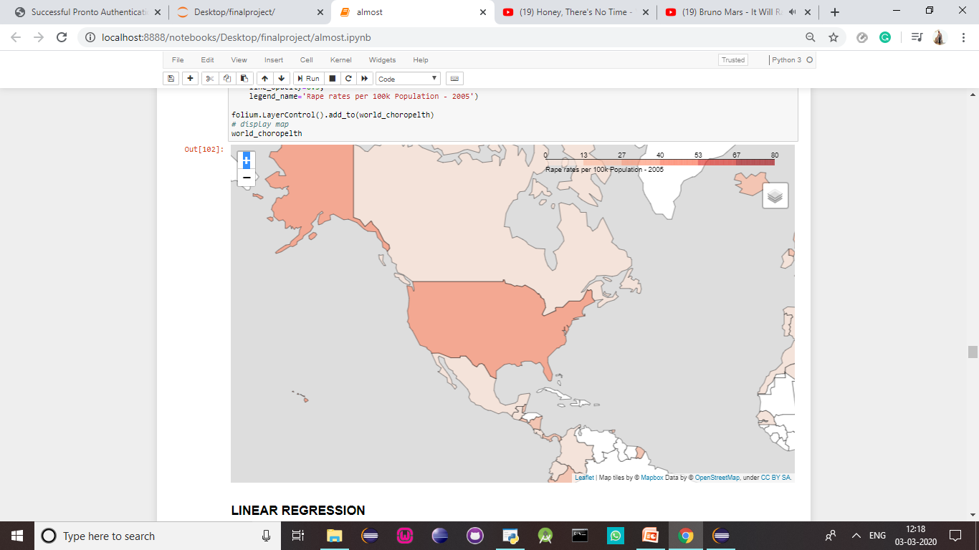**Figure 27**

According to a March 2013 report from the U.S. Department of Justice's Bureau of Justice Statistics, from 1995 to 2010, the estimated annual rate of female rape or sexual assault declined 58%, from 5.0 victimizations per 1,000 females age 12 or older to 2.1 per 1,000.

The 2018 Uniform Crime Report (UCR), which measures rapes that are known to police, estimated that there were 127,258 rapes reported to law enforcement in 2018. However, in 2016 National Crime Victimization Survey (NCVS), which measures sexual assaults and rapes that may not have been reported to the police, estimated that there were 431,840 incidents of rape or sexual assault in 2015.

**4.6 LINEAR REGRESSION (USA)**

Linear regression is one of the most fundamental regression technique used in machine learning. It is based on the premise that one can draw a linear surface such as a line, plane or a hyper-plane that best fits the datapoints in the dataset. Once such linear surface is found using using Linear regression model, then we can easily predict future values using the same linear equation.

The accuracy of model depends on whether the dataset is suited for linear model or is it more suited for non-linear surface such as curve etc.

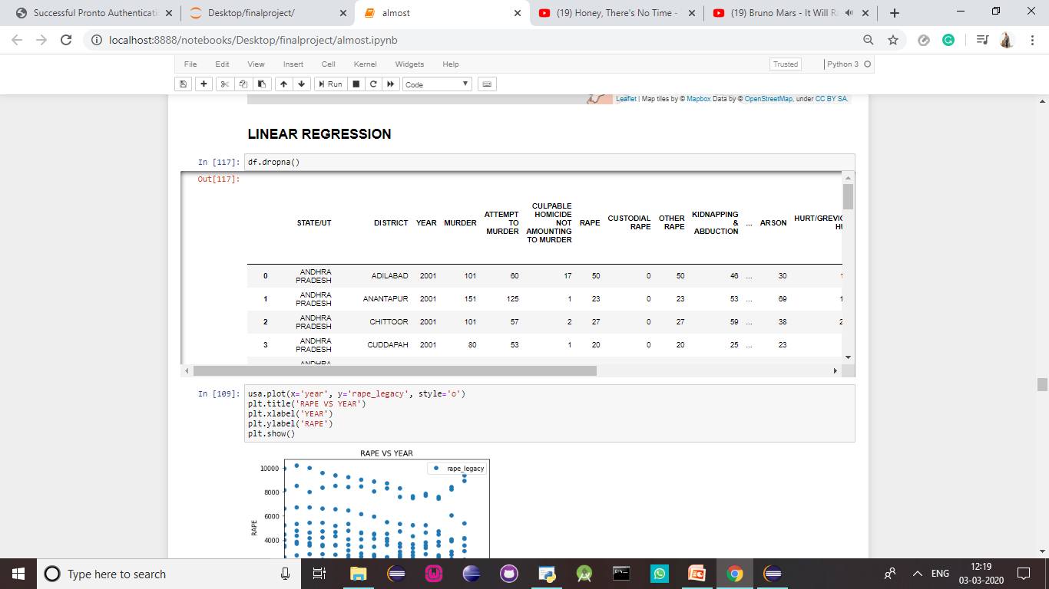

**Table 9**

The regression line we get clearly shows that there has been a decrease in the number of rapes over the decade. While in India, we have seen a steady raise. This poses many questions. One such question is what the values of rape will be in the future years.

You can see that the regression line is now plotted based on the predicted values:

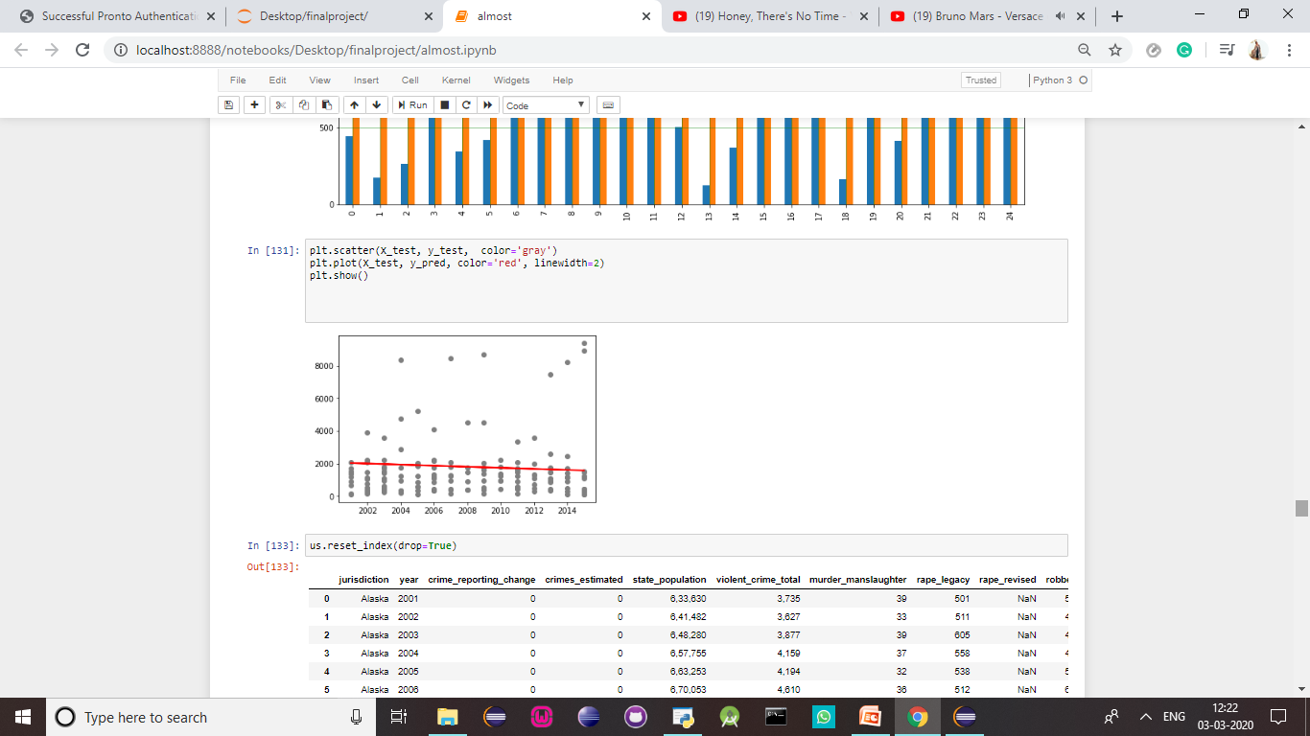

**Figure 28**

The word “normalization” is used informally in statistics, and so the term normalized data can have multiple meanings. In most cases, when you normalize data you eliminate the units of measurement for data, enabling you to more easily compare data from different places. [**Rescaling data**](https://www.statisticshowto.com/what-is-rescaling-data/)**to have values between 0 and 1.**This is usually called feature scaling. One possible formula to achieve this is:

[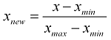](https://www.statisticshowto.com/wp-content/uploads/2015/11/normalize-data.png)

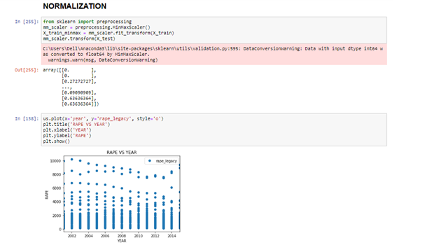

**Figure 29**

A distribution plot displays a distribution and range of a set of numeric values plotted against a dimension. You can display this chart in three different ways, you can just have the value points displayed showing the distribution, or you can display the bounding box which shows the range or use a combination of both. In the distribution plot shown below, you can see there a range and distribution of the rape values displayed for 0.0- 1.0. Each range and distribution box show how data values for a product group is distributed over the average rape rates per district.

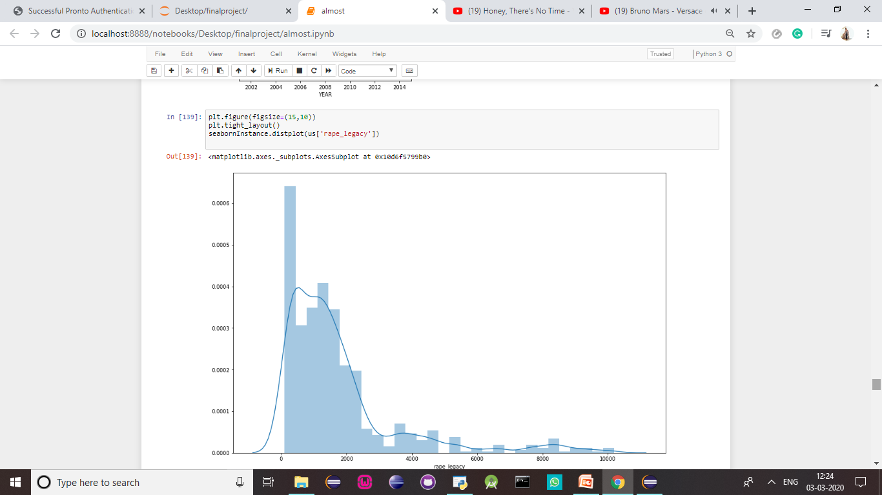

**Figure 30**

** Figure 31**

This graph shows the relation between the actual and predicted values.

From the above calculations we can see that the y intercept has a value of 67881.2 and the slope has a value of -32.90874403. When we apply this to the equation, y=mx+c, to find the value of the dependable variable y. This will help us predict the rape rates per state for the future years. This can help us understand and better prepare for the future law enforcement.

Let us calculate the predicted value of the average value of rapes per state in USA. Once, this is done the value of the predicted variable is ~ 1537.18 per state for a single year.

.

**4.7 COMPARISON OF INDIA VS USA**

From conducting Exploratory data analysis we have better understood the past data. To summarise, let’s look at the various interesting findings we have made.

* Firstly, we find that the state with the highest number of rapes is Madhya Pradesh with an approximate number of 3000
* The one with the lowest number of rapes is Lakshadweep with the approximate value of two per year.
* It is important to note that when you calculate the mean number of rape cases in India, you can see that over the decade it has been approximately ~50
* We then wanted to know the age group for women mostly targeted by rapists and we have found that the women who are at the prime of their age and are usually in colleges or work targeted. The average of age group targeted is from the age of 18-30.
* From the correlogram , you can see that the highest correlation exists between rapes and assault against a woman with the intent to outrage her modesty. This can lead one to believe that rape is conducted with the intent to shame the women or to cause question of her modesty.
* From the world map, you can notice that the number of rapes per capita in India is quite low. This is very contradictory to popular belief that women are not at all safe in India. However, this can also be due to a number of reasons, the main one being that the many number of rapes do not get justice or in many cases, do not even get reported in India due to the various cultural and religious constraints and judgements cast on a woman subject to such abuse.
* We find that the state with the highest number of rapes is California with an approximate number of 11000.
* It is important to note that when you calculate the mean number of rape cases in India, you can see that over the decade it has been approximately ~ 1800
* We then wanted to know the age group for women mostly targeted by rapists and we have found that the women who are at the prime of their age and are usually in colleges or work targeted. The average of age group targeted is from the age of 12-30..
* From the world map, you can notice that the number of rapes per capita in USA is very high. This is very contradictory to popular belief that women are not all safe in USA

**RESULT ANALYSIS**

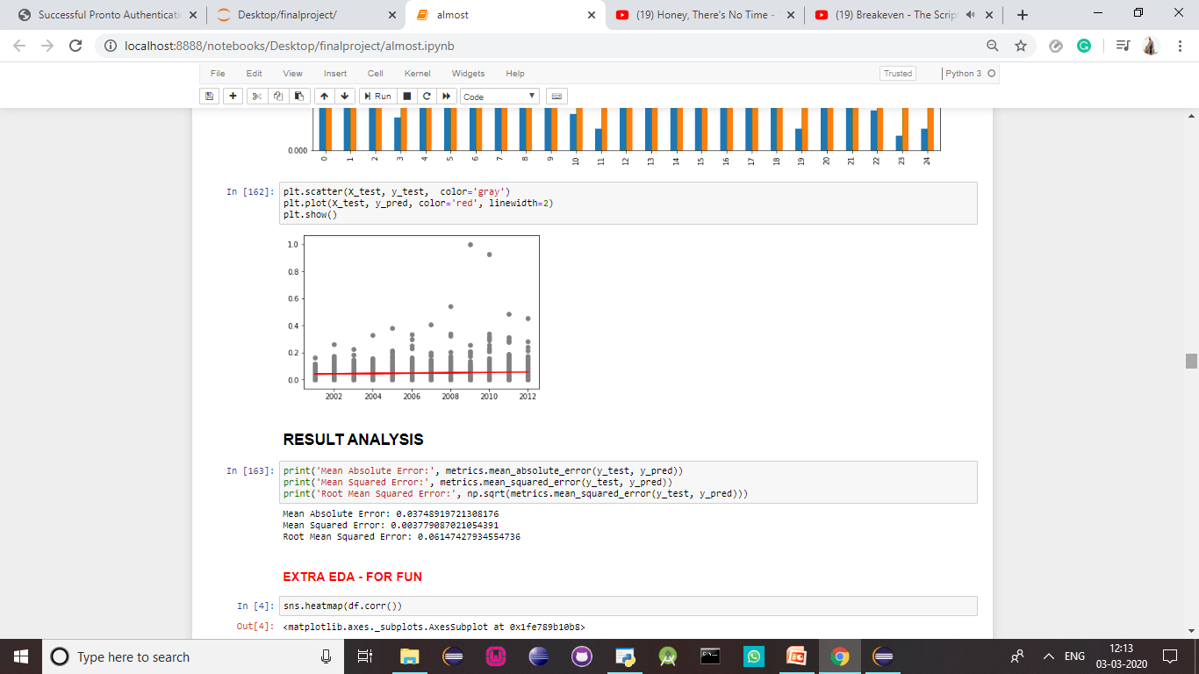

**Figure 32**

From the analysis now we can find that the algorithm will give an average of 35 cases of rape in India.

** Figure 33**

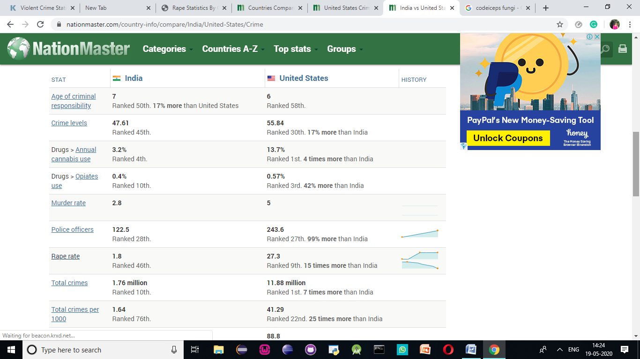

Well let us see some statistics:

India has been characterised as one of the "countries with the lowest per capita rates of rape.

* Delhi has lower crime rate than NewYork [2]
* USA has 16 times more rapes than in India. Even if 50% of the rape cases in India are not reported, and all in USA are reported, they are still 8 times unsafe.
* 2 rapes per 100,000 people for India compared to
* 28.6 rapes/100,000 people for US and
* 24.1 rapes / 100,000 people for UK
* It is estimated that only 53% of rape crimes are reported in India.
* But a UN study estimates just **11%** of rape and sexual assault cases **worldwide** are ever reported.
* 10% in France, 18.3% in USA, and 15% in UK and 13% in Europe are ever reported, rest remain unreported.
* Also, in UK, 26% of all sexual offences (including rape) reported to police are not even recorded as crimes.
* In some places in USA, the victims were forced to take a polygraph test before rape is reported.

**4.8 K MEANS CLUSTERING ( INDIA )**

K- means is one of the clustering methods. Clustering is an unsupervised machine learning algorithm. Clustering is nothing but grouping similar records together in a given dataset. K- Means is a non- hierarchical clustering algorithm. It is an iterative algorithm which tries to partition the dataset into a pre-defined number of non-overlapping clusters(k) by minimizing the sum of squared distances from each data point to the cluster centroid (Within sum of squared distances- WSS). Let us see how it works:

* Pre-define the no. of clusters (k)
* Initialize cluster centroids by randomly selecting K data points.
* Calculate the WSS distances between each data point to all the cluster centroids.
* Assign each data point to the closest centers
* Steps 3 and 4 will be iterated until there is no reassignment of data points is required.



**Figure 34**

Now, let’s look at the same graph with multiple variables:



**Figure 35**



**Figure 36**



**Figure 37**

Now, we have to calculate the number of clusters that should be made.

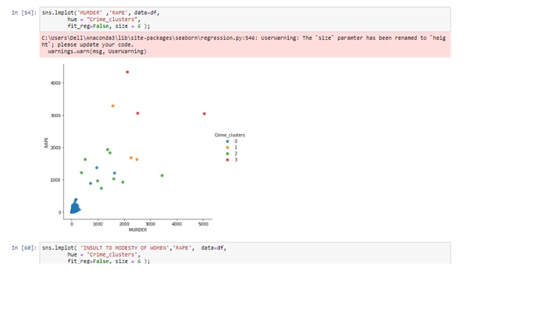

**Figure 38**

Here,we look at the four clusters formed on the different states in India when we bring in the two variables RAPE and MURDER to better understand the safer and most dangerous states in India.

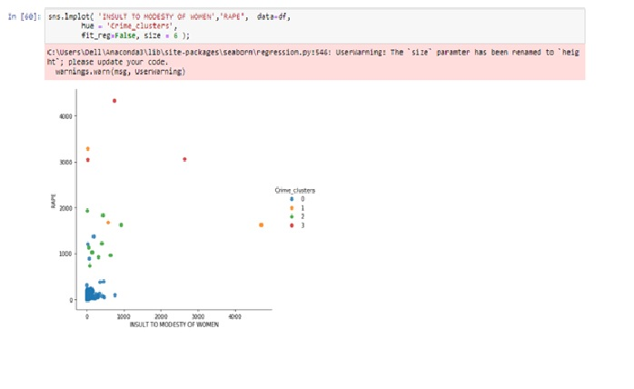

**Figure 39**

Here, we look at the four clusters formed on the different states in India when we bring in the two variables RAPE and INSULT TO THE MODESTY OF WOMEN to better understand the safer and most dangerous states in India.

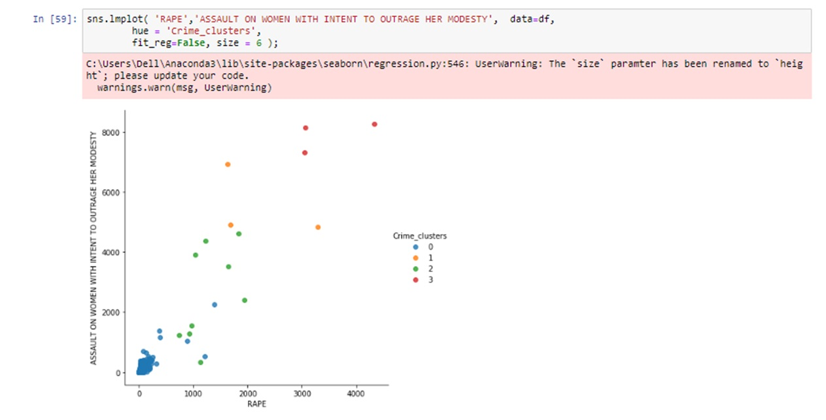

**Figure 40**

We look at the four clusters formed on the different states in India when we bring in the two variables RAPE and ASSAULT ON WOMEN WITH THE INTENT TO OUTRAGE HER MODESTY to better understand the safer and most dangerous states in India. These seem to create the most well defined clusters. This will be proven when you find out that these two variables have the highest correlation as well.

**CORRELATION**

Correlation is used to test relationships between quantitative variables or categorical variables. In other words, it’s a measure of how things are related. The study of how variables are correlated is called correlation analysis.The main result of a correlation is called the **correlation coefficient** (or "r"). It ranges from -1.0 to +1.0. The closer r is to +1 or -1, the more closely the two variables are related.If r is close to 0, it means there is no relationship between the variables. If r is positive, it means that as one variable gets larger the other gets larger. If r is negative it means that as one gets larger, the other gets smaller (often called an "inverse" correlation).

While correlation coefficients are normally reported as r = (a value between -1 and +1), squaring them makes then easier to understand. The square of the coefficient (or r square) is equal to the percent of the variation in one variable that is related to the variation in the other. After squaring r, ignore the decimal point. An r of .5 means 25% of the variation is related (.5 squared =.25). An r value of .7 means 49% of the variance is related (.7 squared = .49).

A correlation report can also show a second result of each test - statistical significance. In this case, the significance level will tell you how likely it is that the correlations reported may be due to chance in the form of random sampling error. If you are working with small sample sizes, choose a report format that includes the significance level. This format also reports the sample size.

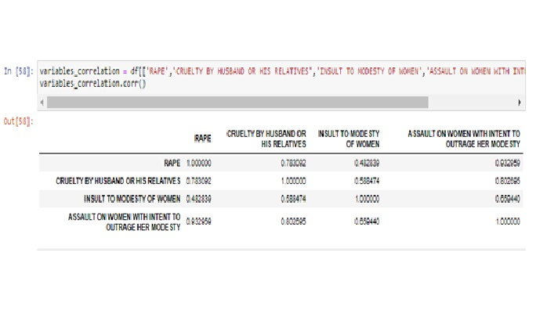

**Figure41**



**Figure 42**



**Figure 42**

From the following, we understand that these are the safest to the most dangerous sates in our country. This study shows the various characteristics that affect the conditions of rape in India and does an in depth study of the comparisons of both the countries, India and USA. India is known as a third world country and is said to be a ‘developing country’. USA is considered to be a first world country and economically developed. However, we see that even though India is considered to be a third world country, women are much safer. A recent study showed that ~50 of rapes go unreported while in the US ~10 percent only get reported. So even if we were to double the amount of rape committed per capita, you can see that India is considerably safer than the US. This can be because of a number of reasons.

In our predictions, we can see that the y intercept for USA has a value of 67881.2 and the slope has a value of -32.90874403. When we apply this to the equation, y=mx+c, to find the value of the dependable variable y. This will help us predict the rape rates per state for the future years. This can help us understand and better prepare for the future law enforcement. The predicted value of the average value of rapes per state in USA, is found to be the value of ~ 1537.18 per state for a single year.

From the calculations we made for India, we can see that the y intercept has a value of -2.585 and the slope has a value of 0.0001. When we apply this to the equation, y=mx+c, to find the value of the dependable variable y. This will help us predict the rape rates per state for the future years. This can help us understand and better prepare for the future law enforcement. Let us calculate the predicted value of the average value of rapes per state in India. Once, this is done the value of the predicted variable is ~34.7 per state for a single year.

India has a rape rate per capita of 1.8 and is ranked 46th in the world among crimes of rape committed. USA has a rape rate per capita of 27.3 and is ranked 9th. 15 times more than India.

**REFERENCES**

1. Approach of Predictive Modeling on Crime Against Women Problem ,Priya Gandhi, Shayog Sharma (Department of Computer Science & Engineering, Geeta Engineering college, panipat, india . )
2. Crime rate prediction using data clustering algorithms , Omkar Vaidya, Sayak Mitra, Raj Kumbhar, Suraj Chavan, Mrs. Rohini Patil (Department of Computer Engineering, Terna Engineering College, Mumbai University, India )
3. Crime against indian women –women crime, susceptibility indexes (wcsi): a principal component analysis , prarthna agarwal goel , vandana yadav , delhi university, india.
4. Prediction of Crime Rate Using Data , Clustering Technique ,A. Anitha ( VIT University)
5. Research Corner , Regression Analysis for Prediction: Understanding the Process , Phillip, Associate Professor, Hardin-Simmons University, Department of Physical Therapy, Abilene, TX Professor & Shelton-Lacewell Endowed Chair, Hardin-Simmons University, Department of Physical Therapy, Abilene, TX
6. Yamuna and Sudha Bhuva Neswa ,DataMining techniques to Analyze and predict crimes
7. Predictive Analytics: Opportunities, Challenges and Use Cases by Lityx.
8. Applied Predictive Analytics “Principles and Techniques for the Professional Data Analyst” by Dean Abbott
9. Understanding Environmental Factors that Affect Violence in Salinas, California Clarke, Jason A.; Onufer, Tracy L. Dec,2009, Malathi, Dr. S. Santhosh Baboo , 2011.
10. Poisson-Based Regression Analysis of Aggregate Crime Rates D. Wayne Osgood,2000.
11. Forecasting Crime: A City Level Analysis John V. Pepper Department of Economics University of Virginia.Ch-6.
12. Analysis of Criminal Behaviour Using a Logistic Regression Model Maria Jofre Department of Industrial Engineering, University of Chile.
13. Jiawei Han, Micheline Kamber, Jian Pei, “DATA MINING Concepts and Techniques”, Publisher: Morgan Kaufmann, Third Edition 2012, ISBN 978- 0-12-381479-1
14. R. Kiani, S. Mahdavi, A. Keshavarzi, “Analysis and Prediction of Crimes by Clustering and Classification”, *(IJARAI)* International Journal of Advanced Research in Artificial Intelligence, Vol. 4, No.8, 2015, PP. 11-17.
15. V. Jain, Y. Sharma, A. Bhatia, V. Arora, “Crime Prediction using K-means Algorithm”, Global Research And Development Journal for Engineering, Volume 2 Issue 5, April 2017, PP. 206–209.
16. T. Sonawanev, S. Shaikh, S. Shaikh, R. Shinde, A. Sayyad, “Crime Pattern Analysis, Visualization And Prediction Using Data Mining”, IJARIIE, Vol-1 Issue-4 2015, PP. 681-686.
17. J. Agarwal, R. Nagpal, R. Sehgal, “Crime Analysis using K-means Clustering”, International Journal of Computer Applications, Volume 83 – No4, December 2013.
18. Malathi A., Dr. S. Santhosh Baboo, “An Enhanced Algorithm to Predict a Future Crime using Data Mining”, International Journal of Computer Applications, Volume 21-No.1, May 2011, PP. 1-6.
19. M. Gupta, B. Chandra and M. P. Gupta, “Crime Data Mining for Indian Police Information System”, Computer Society of India, 2008, PP. 388-397.
20. Grady Booch, James Rumbaugh, Ivar Jacobson, “The Unified Modeling Language User Guide”, Publisher: Addison Wesley, First Edition October 20, 1998, ISBN 0-201-57168-4
21. *https://www.kaggle.com/c/sf-crime/data*
22. L. Ding et al., “PerpSearch: an integrated crime detection system”, 2009 *IEEE* 161-163 ISI 2009, June 8-11, 2009, Richardson, TX, USA.
23. D.E. Brown 1998, ”The regional crime analysis program (RECAP): A frame work for mining data to catch criminals", In Proceedings of the IEEE International Conference on Systems, Man, and Cybernetics, Vol. 3, Pp. 2848-2853
24. Yamuna.S, N.Sudha Bhauvaneswari D, Data mining Techniques to Analyze and Predict Crimes, International Journal of Engineering And Science(IJES) Vol-1,Issue-2,PP 243-247.
25. Sylvia Walby, Improving the statistics on violence against women, Statistical Journal of the united nation ECE 22(2005)193-216.
26. S.Bewley, J.Friend and G.Mezey, Eds, Violence against Women, London: Royal College of Obestricians and Gynaecologists, 1997.
27. Malathi.A and Dr.S.Santhosh Baboo. Article: an enhanced algorithm to predict a future crime using data mining. International Journal of Computer Applications,21(1):1-6, May2011.Published by foundation of Computer Science.
28. A.Buczak and C.Gifford, ‘Fuzzy association rule mining for community crime pattern discovery’, in ACM SIGKDD workshop on intelligence and security Informatics, Washington, D.C., 2010, PP.1-10.
29. Crimereports.com,2015.[online].Available:http://www.crimereports.com.[Accessed:20-May-2015].
30. Anshu Sharma,Shilpa Sharma 2012 An Intelligent Analysis of Web Crime Data using Data Mining, International Journal of Engineering And Innovative Technology(Ijeit)2(3)
31. Devendra Kumar Tayal et al., Crime detection and criminal identification in India using data mining techniques,AI & Soc(2015) 30, pp.117-127.
32. Roslin V.Hausk and Hsinchun Chen., Coplink: A Case of Intelligent Analysis and Knowledge Management, Proceedings of International Conference on Information Systems, 1999, pp.15-28.
33. Rasoul kiani, Siamak mahdavi, Amin Keshavarzi, Analysis and Prediction of Crimes by clustering and Classification.(IJARAI) International Journal of Advanced Research in Artificial Intelligence,Vol-4,No:8,2015
34. Amarnathan, L.C.(2003) Technological Advancement: Implications for the Crime, the Indian Police Journal, April-June.

**TEAM NUMBER – 1**

**Name:** PREETI RACHEL JASPER



**Register Number:** 17BCS0003

**Date of Birth:** 19/12/1997

**Blood Group:** B+ve

**Phone Number:** 9003306860

**Email:** preetirachel.jasper2017@vitstudent.ac.in

**Address:** BETHELS, TRA C6, TC 26/2139,

STATUE ROAD, TRIVANDRUM-1

**Pin Code:** 695001

**TEAM NUMBER – 2**



**Name :** DINESH S

**Register Number:** 17BCS0123

**Date of Birth:** 15-09-1999

**Blood Group:** B+

**Phone Number:** 7871114428

**Email:** dineshs15091999@gmail.com

**Address:** No.9,pillaiyar kovil street arunagiripettai,

Mothakal post village,mottupalayam,kammavanpettai,

Vellore-632319

**TEAM NUMBER – 3**



**Name**: KAMESHWARAN E

**Register Number**:17BCS0074

**Date of Birth**:16-02-2000

**Blood Group**: O+

**Phone Number**: 9486625185

**Email**:kamesh1620@gmail.com

**Address:** No.40/47 Mettu street Pazhampet,Chetpet

Tiruvannamalai District,606801,Tamil Nadu, India